Nike Azure Days

Azure Infrastructure Orchestration and Automation

Linux/OSS Workshop Guide

January 24th, 2018

© 2018 Microsoft Corporation. All rights reserved. This document is confidential and proprietary to Microsoft. Internal use only. This document is for informational purposes only. MICROSOFT MAKES NO WARRANTIES, EXPRESS OR IMPLIED, IN THIS SUMMARY.

This document is provided "as-is." Information and views expressed in this document, including URL and other Internet Web site references, may change without notice. You bear the risk of using it.

Some examples are for illustration only and are fictitious. No real association is intended or inferred.

# Azure Infrastructure and Automation - Linux Workshop Guide

## Overview

This workshop guide is intended to walk you through the automated deployment of a Linux/OSS environment in Azure. This includes monitoring with OMS, secrets management with KeyVault and deployment of a load-balanced nginx proxy serving static content from Azure Blob Storage.

## What You Will Build

A simple application deployment on IaaS infrastructure consisting of:

Virtual Networks, a Network Load Balancer, and a Public IP

Operations Management Suite

KeyVault

Azure Storage

Virtual Machines

## Requirements

* Terminal emulator running Bash or Zsh
* Git commandline
* Code Editor (Visual Studio Code recommended)
* Text Editor (such as notepad or textedit)
* Azure CLI v2
* Blobxfer or Azure Storage Explorer (blobxfer recommended)
* Azure Subscription with Owner role

## Help References

|  |  |
| --- | --- |
| Bash for Windows 10 Installation | https://docs.microsoft.com/en-us/windows/wsl/install-win10 |
| Git Installation | <https://git-scm.com/book/en/v2/Getting-Started-Installing-Git>  If using the Windows Subsystem for Linux, use ‘apt-get install git’ |
| Visual Studio Code | https://code.visualstudio.com/ |
| Azure CLI v2 Installation | <https://docs.microsoft.com/en-us/cli/azure/install-azure-cli>  If using Windows Subsystem for Linux, you need to install Azure CLI into the Linux subsystem. Do not install the Windows binary, as our scripts are using BASH. |
| Blobxfer Python tool | <http://blobxfer.readthedocs.io/en/latest/01-installation/>  Make sure the dependencies are installed BEFORE using pip or pip3 |
| Azure Storage Explorer | https://azure.microsoft.com/en-us/features/storage-explorer/ |

# Step 1 – Clone GitHub Repository and Open Notepad/TextEdit

## Overview

The first step involves cloning a Github repository that includes the scripts and configuration files that will be used in this workshop.

## Detailed Steps

1. Open your terminal emulator running BASH or ZSH and make a directory to clone the Github respository into.

mkdir <directory name>

1. Change the working directory to your newly created one and then clone the repository from Github.

cd <directory name>

git clone https://github.com/lorax79/AzureDays

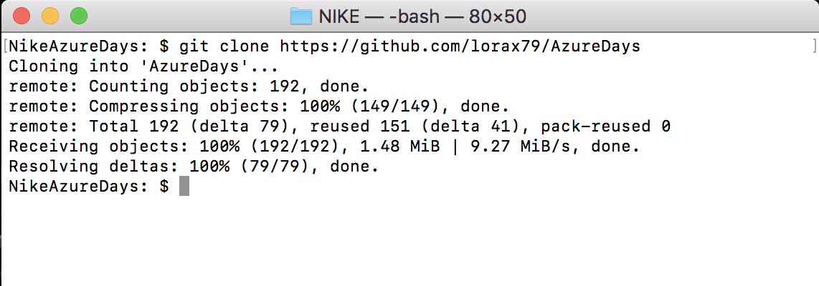

1. Open Notepad, TextEdit or another tool to keep track of IDs, names, and other items you use in various steps of the workshop.

# Step 2 – Open cloned folder in Visual Studio Code

## Overview

This step involves opening the directory we just cloned from github in Visual Studio Code.

## Detailed Steps

1. Open Visual Studio Code
2. Select “Open Folder…” under “Start”

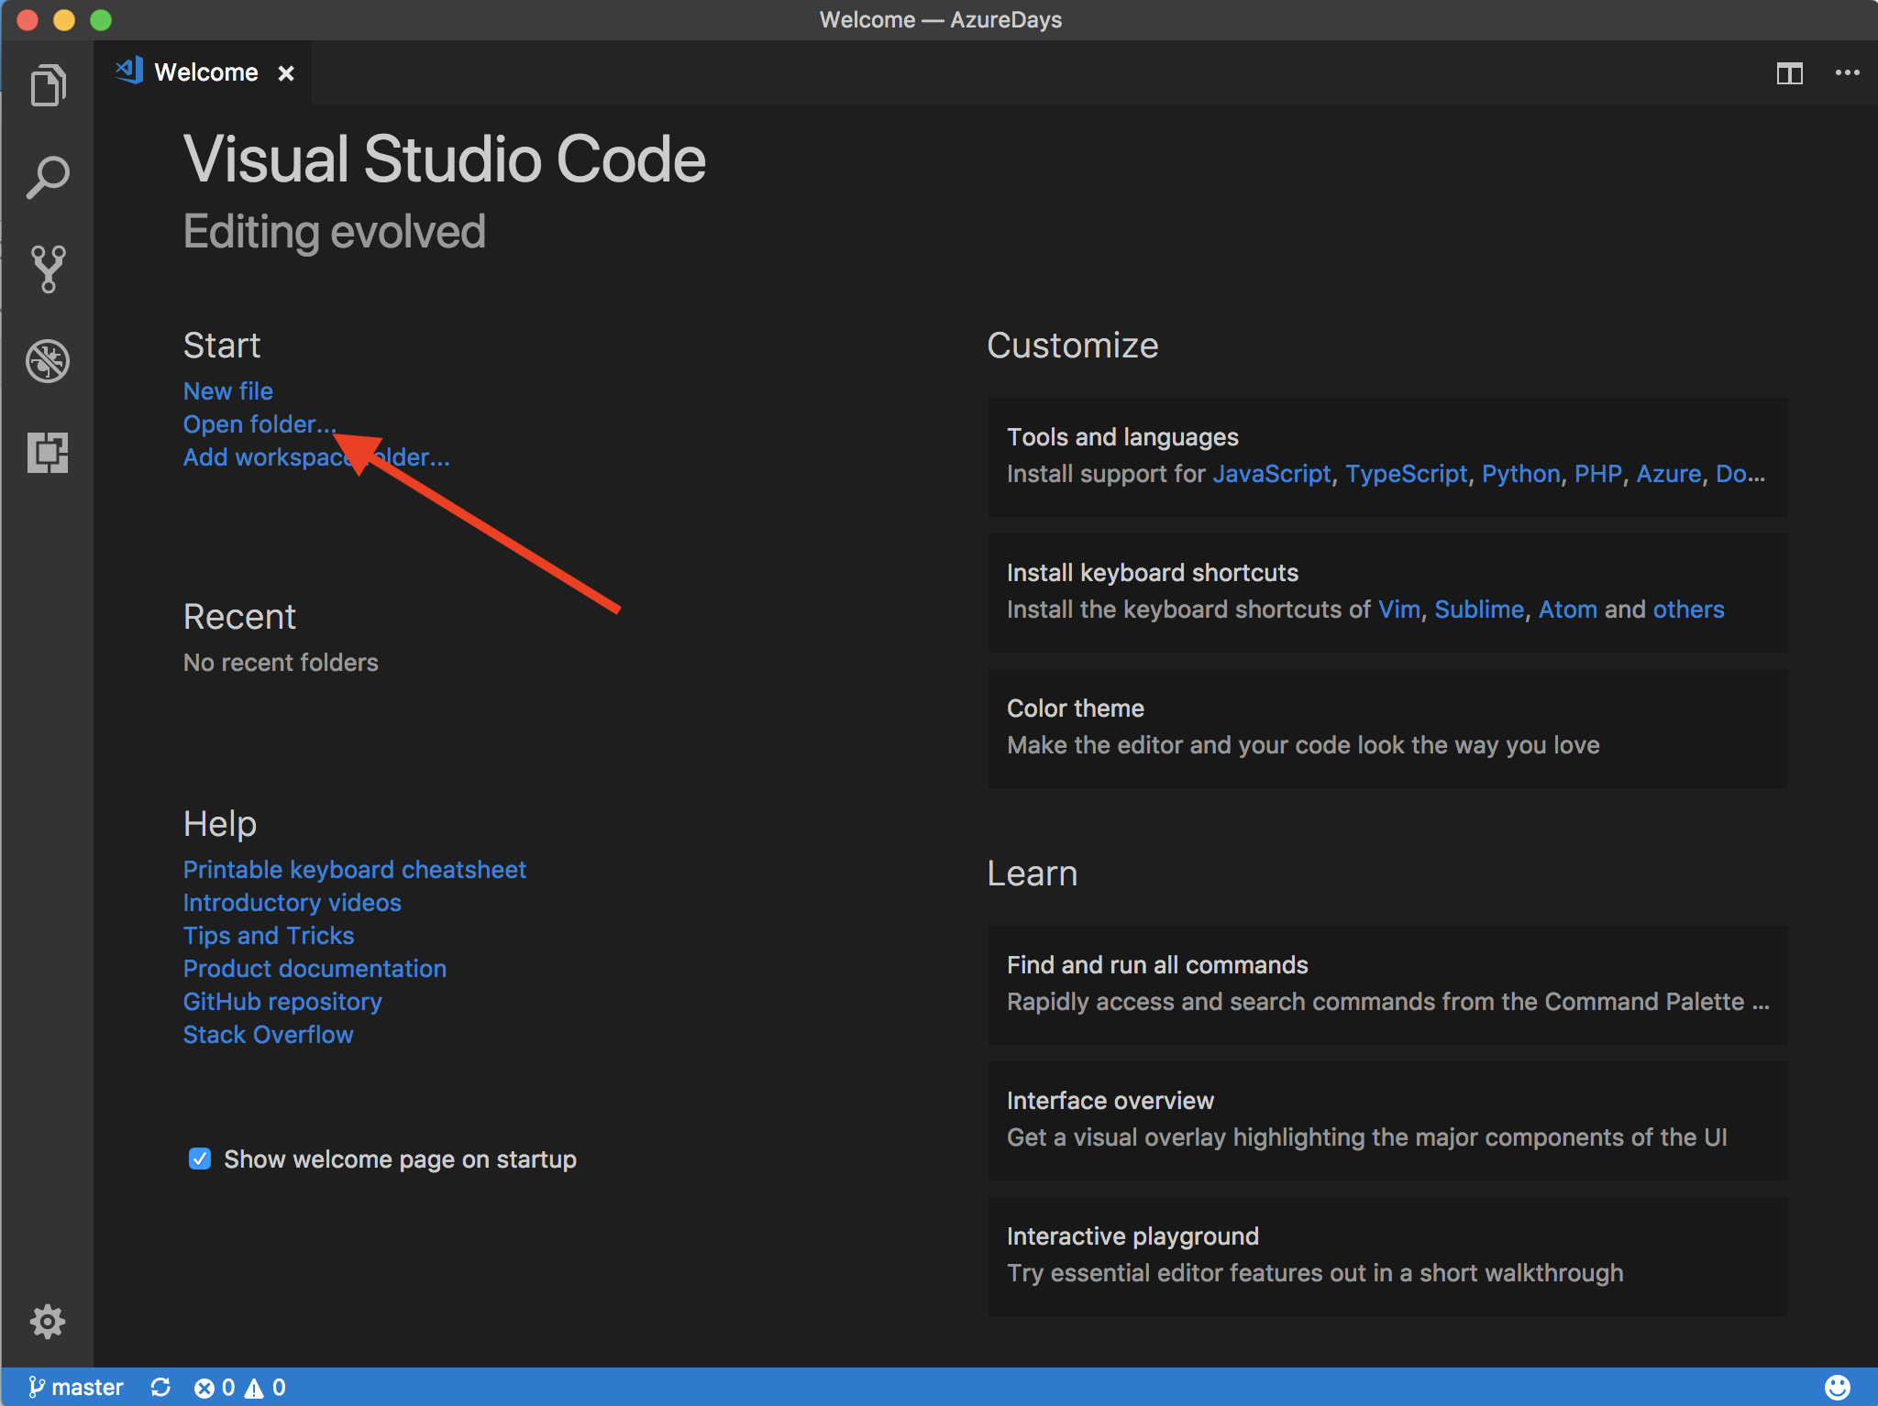

1. Select the directory you just cloned with git.

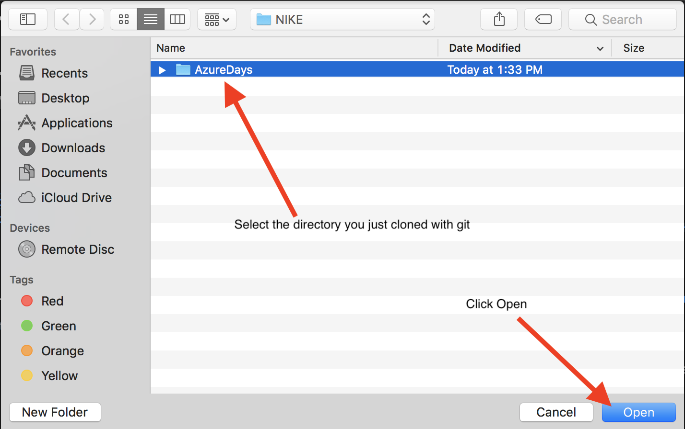

1. If you click the explorer icon in Visual Studio Code, you should see the contents of the directory.

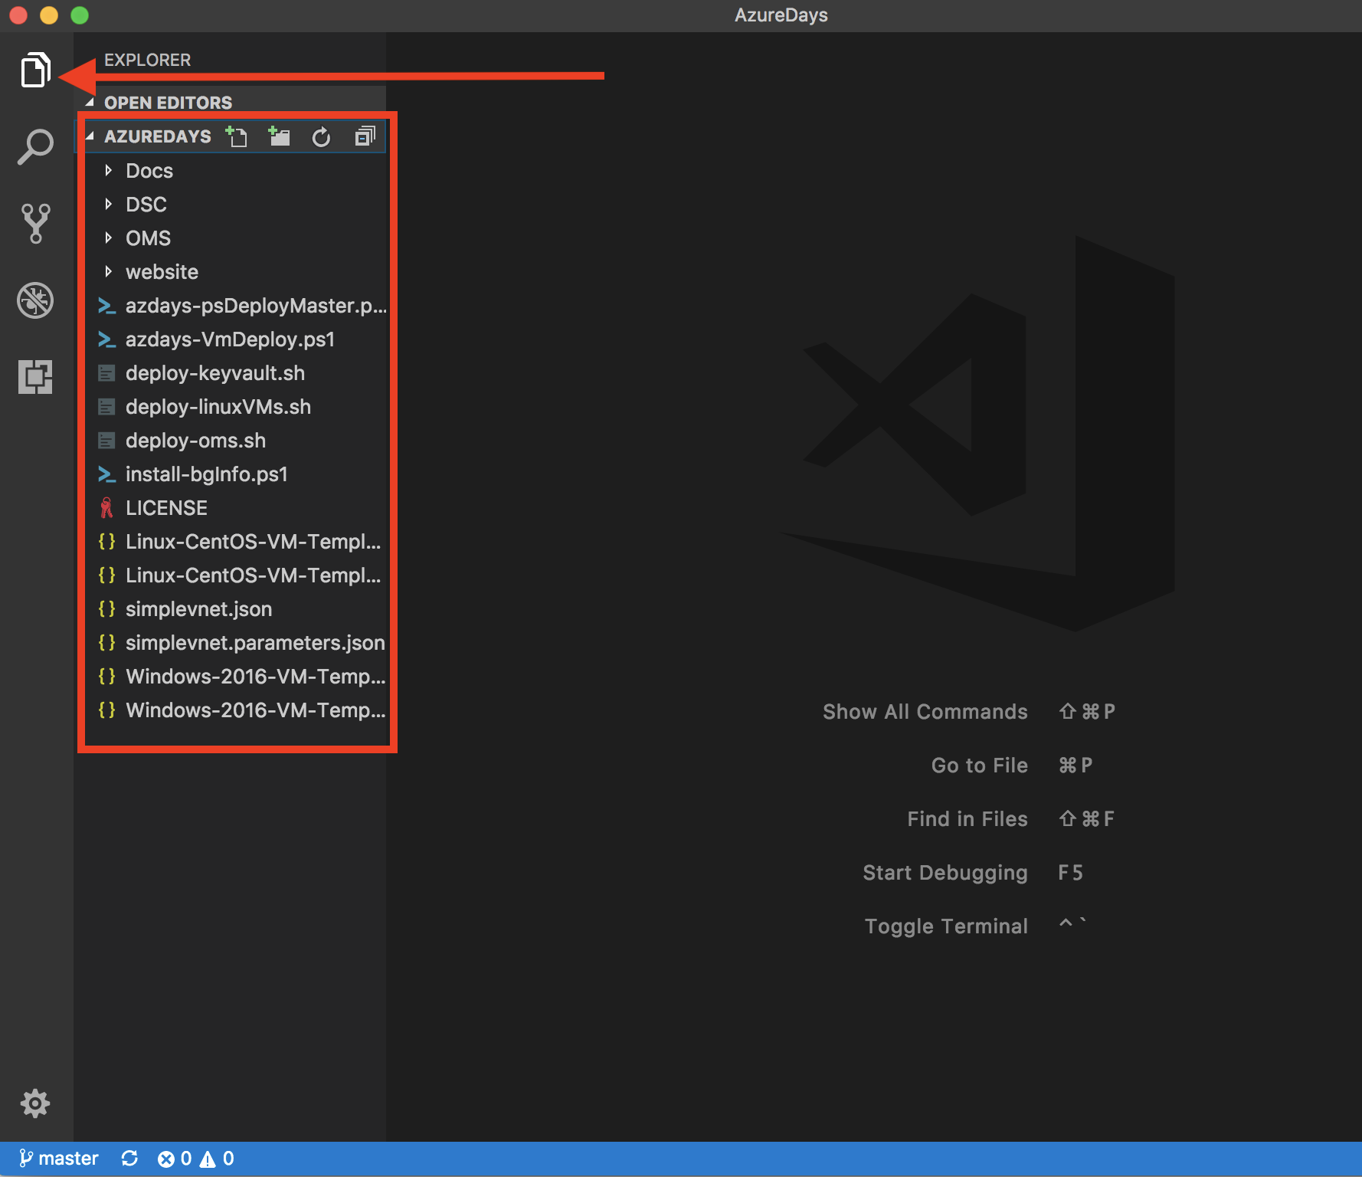

# Step 3 – Login to your subscription via Azure CLI v2.0

## Overview

This workshop involves deploying ARM templates and running scripts from the command line. The Azure CLI v2.0 is the tool we will be using to deploy the ARM templates. This step will log us into the Azure CLI v2.0. If you have not yet installed the Azure CLI v2.0 you can find the instructions here: <https://docs.microsoft.com/en-us/cli/azure/install-azure-cli>

## Detailed Steps

1. From the command line type “az login”.

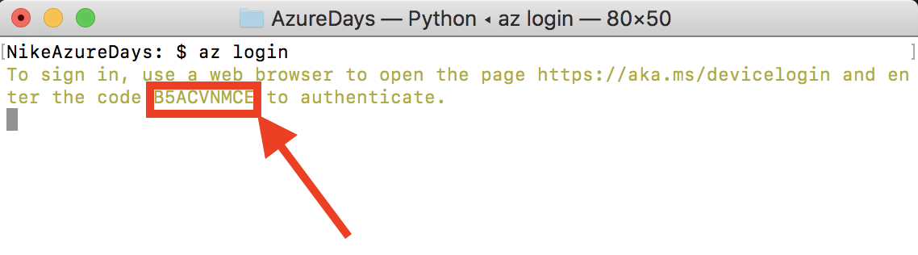

1. Go to <https://aka.ms/devicelogin> in a web browser and enter the code from running az login.

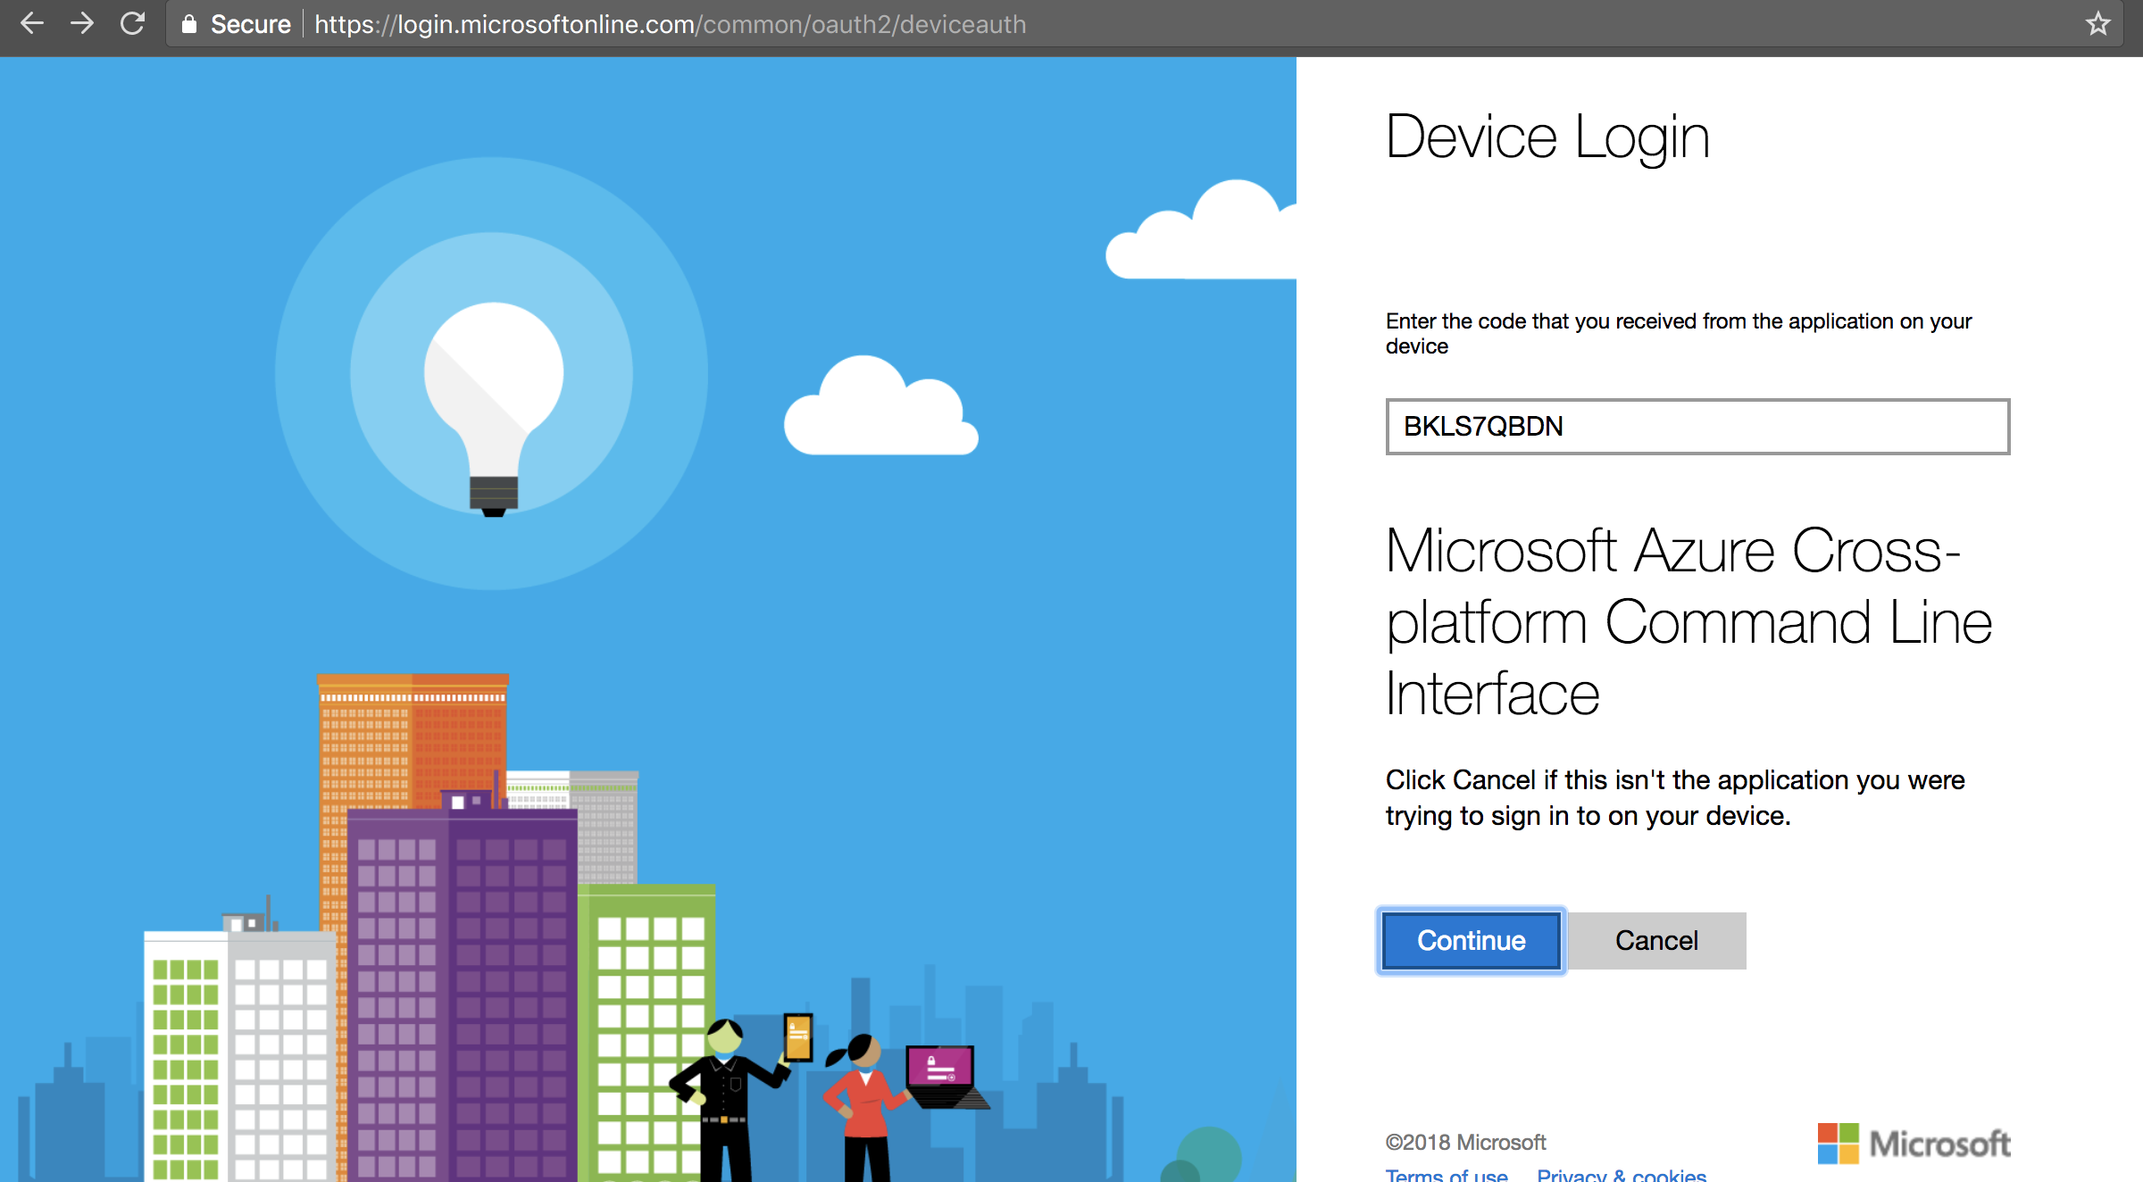

1. Login with the credentials for your Azure subscription.

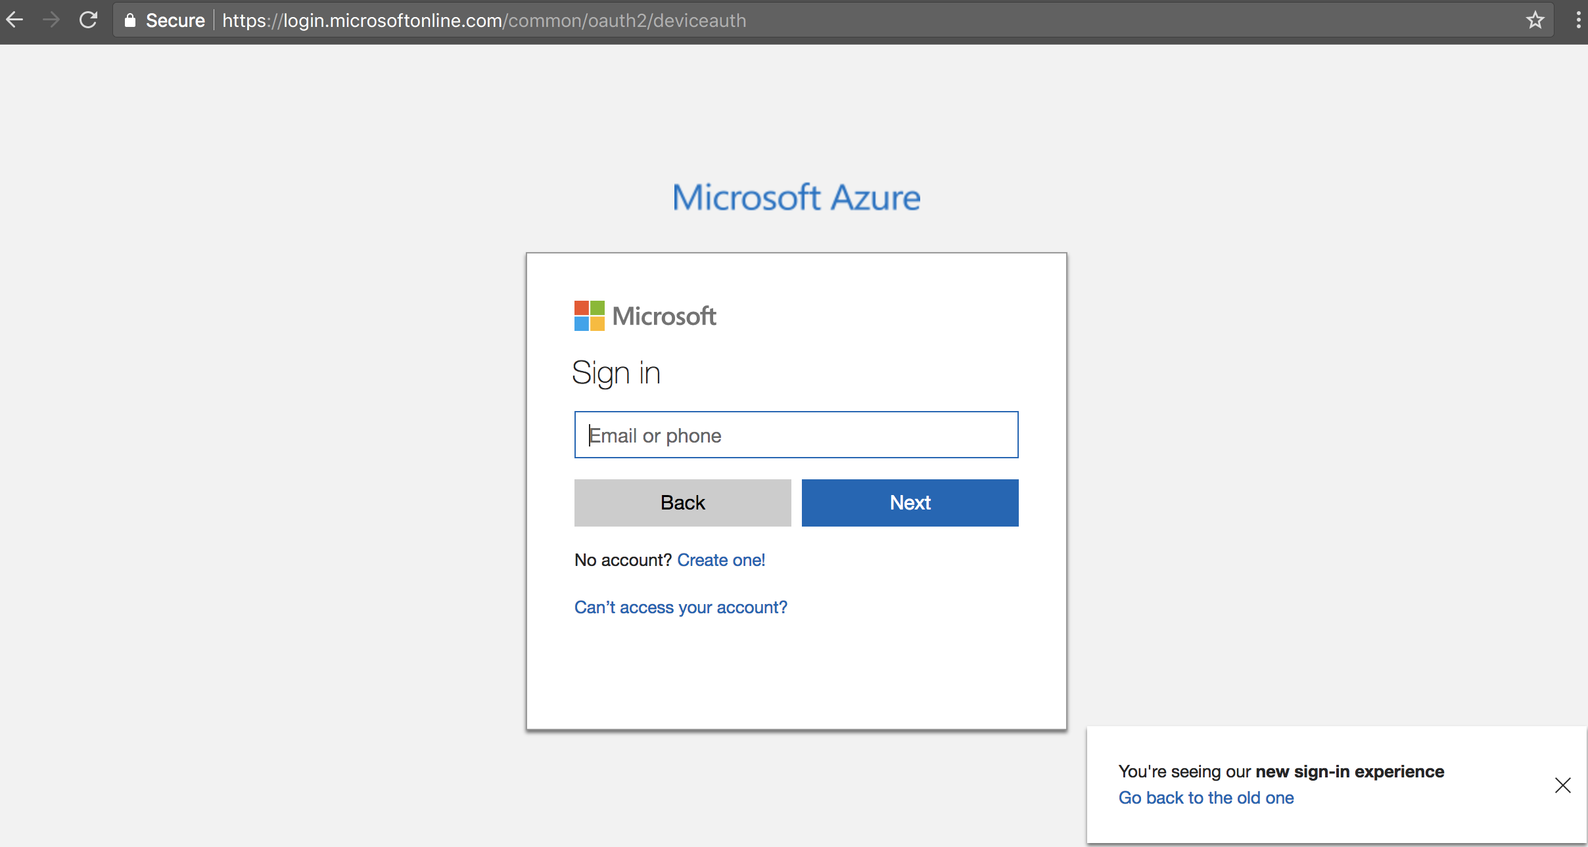

1. You should then be presented with a success screen in the browser when you are done and you will then see JSON in your CLI with your subscription information and you will be back at your prompt.

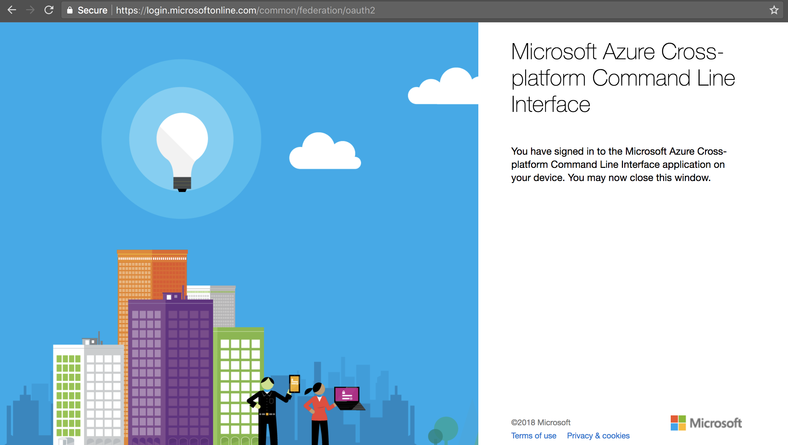

1. The JSON that is displayed when the login completes includes your subscription ID. To display it again type “az account show”. **Copy and paste the value of the “id” field into your notepad editor**. This is your subscription ID, and will be used for automating other steps in the deployment.

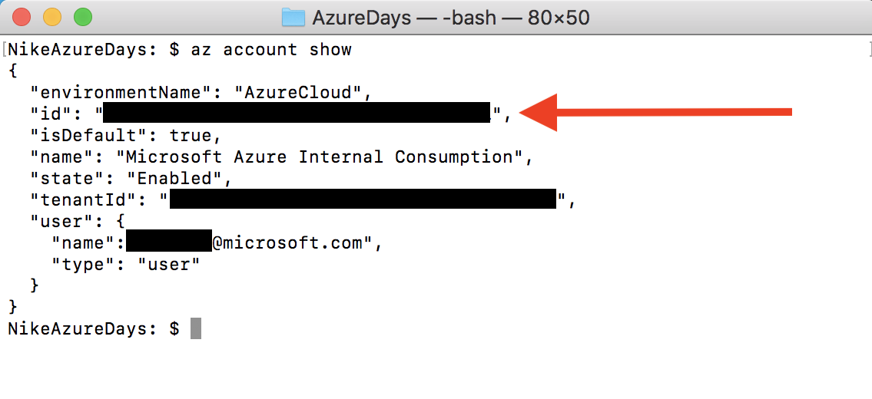

# Step 4 – Set variables and parameters for Operations Management Suite Deployment

## Overview

In this step you will edit an ARM template parameters file and a shell script. You will be setting values that will be used in the creation of an OMS workspace, automation account, and recovery vault. These files will be edited with Visual Studio Code.

## Detailed Steps

1. Open the OMS/omsMaster.paramaters.json file in Visual Studio Code and specify the empty parameters as seen in the screenshot below. Make the parameters as unique as possible by including your name and some numerical value, e.g. “jorsmith-nikeoms1223” Also, be sure to change the password to something unique and secure. **Make note of the omsWorkSpaceName value in your notepad**.

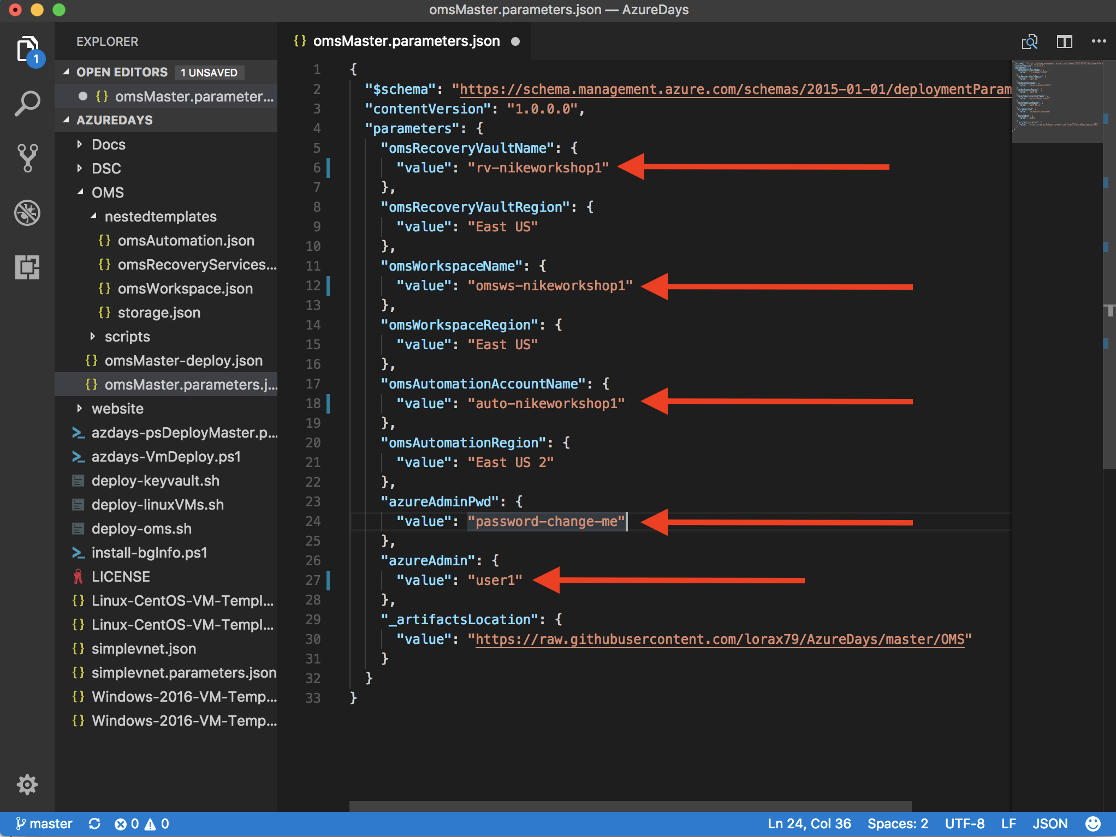

1. Open the oms-deploy.sh script. Set the variables. **Make note of what you set for the “SUPPORTRG” variable in your notepad**. This is the name of the resource group that will be created as a part of this workshop and it is the logical container where some of the resources you deploy will end up. For SUSBSCRIPTIONNAME use the value of your Subscription ID that you took note of at the end of Step 3. Set OMSWORKSPACENAME to the same value you set and took note of in the omsMaster.parameters.json file from above.

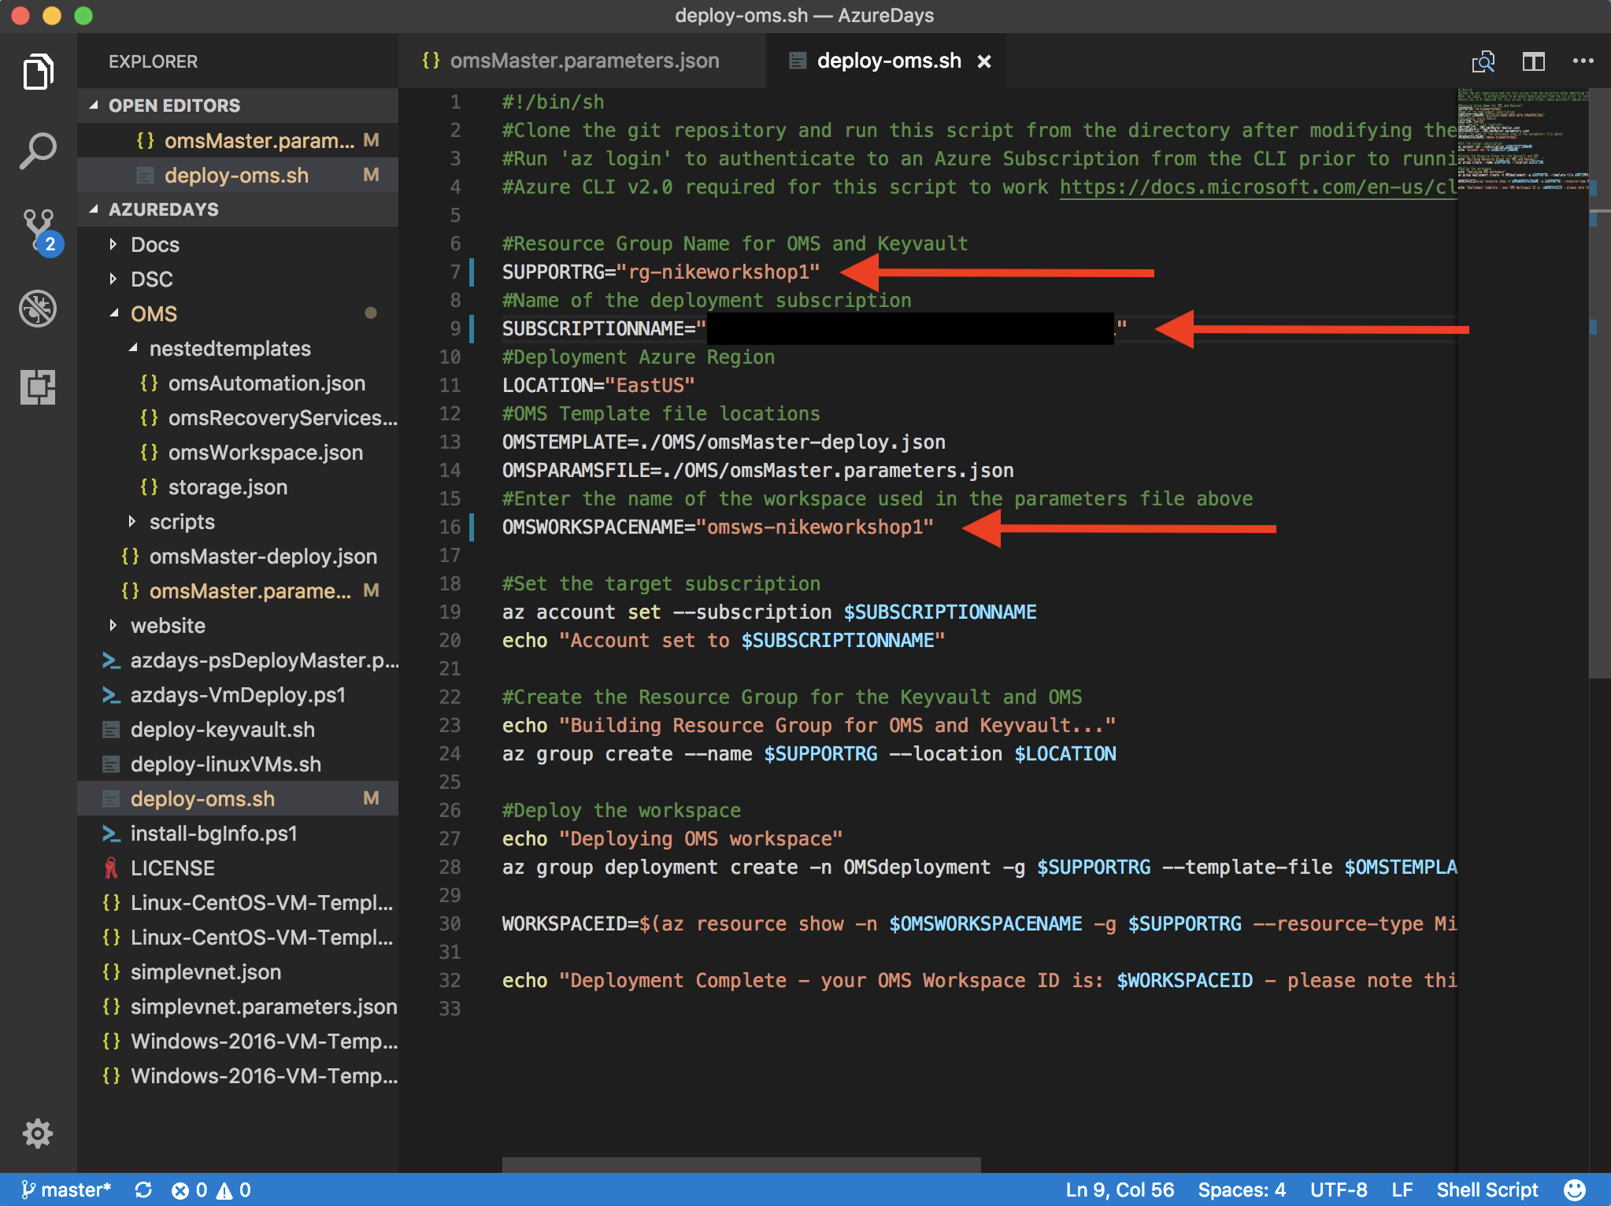

1. Save your changes to the file. File -> Save or Ctrl+s.

# Step 5 – Deploy OMS Workspace and View Deployment in Portal

## Overview

In this step you begin deploying resources. You will execute the deploy-oms.sh script. The deploy-oms.sh script creates a resource group and then deploys an ARM template. The template takes a few minutes to run. During this time, we will login to the Azure Portal and view the status of the ARM template deployment. At the end of this step you will also have the ID and key for your OMS workspace.

## Detailed Steps

1. Run “sh deploy-oms.sh” at the command line.

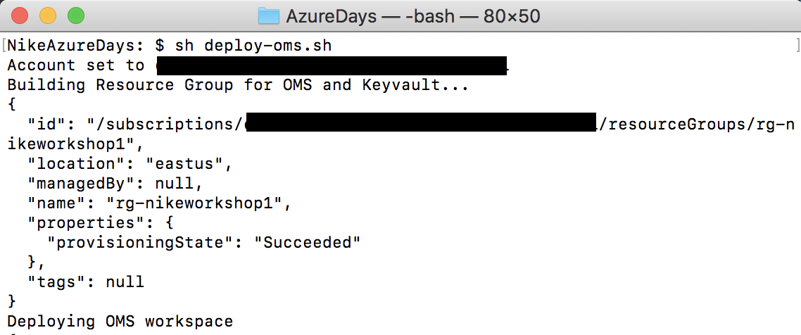

1. This will take 5-10 minutes to run. While this is running, login to the Azure Portal with the credentials for your subscription. <https://portal.azure.com>
2. Once you are logged into the portal, click on Resource Groups.

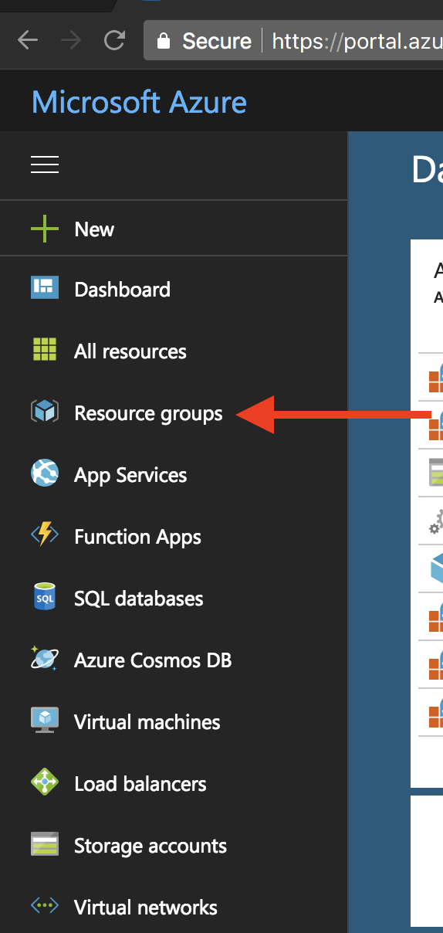

1. Now click on the resource group you took note of from step 4.2 above. Then click on “Deployments”. Here you will see the deployments that are running as a result of the script we ran. Clicking on the deployments will show you the operations that are running and what resources the ARM template is deploying.

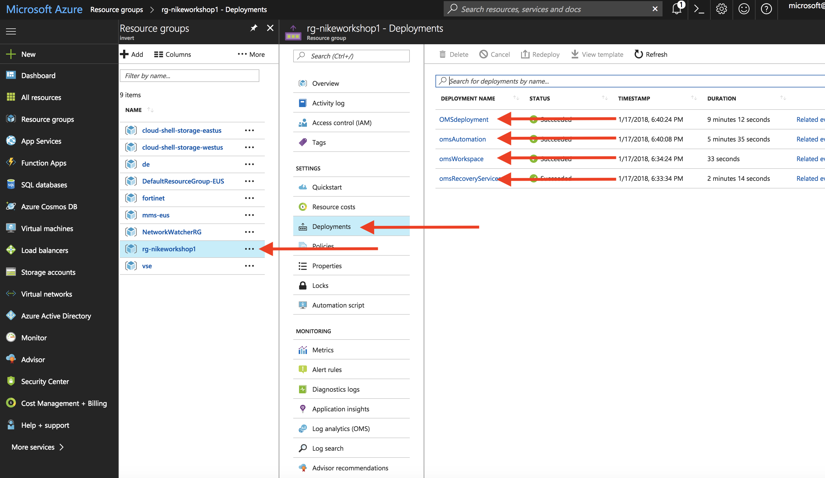

1. When the deploy-oms.sh script is complete it will show you the ID for your OMS workspace. **Take note of this in your notepad.**

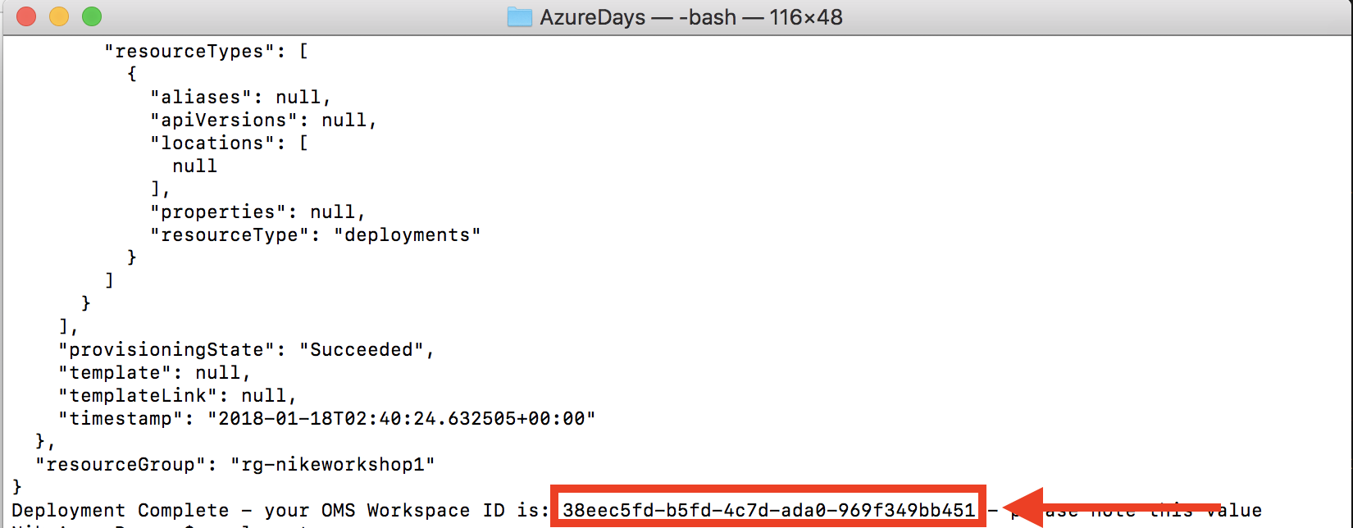

1. The last piece of information needed is the OMS workspace key. This, combined with the workspace ID, will allow the virtual machines we deploy later to send logs and metrics to OMS. Go back to the portal in your web browser. In the search window at the top, enter “Log Analytics” and click the link for the “Log Analytics” service.

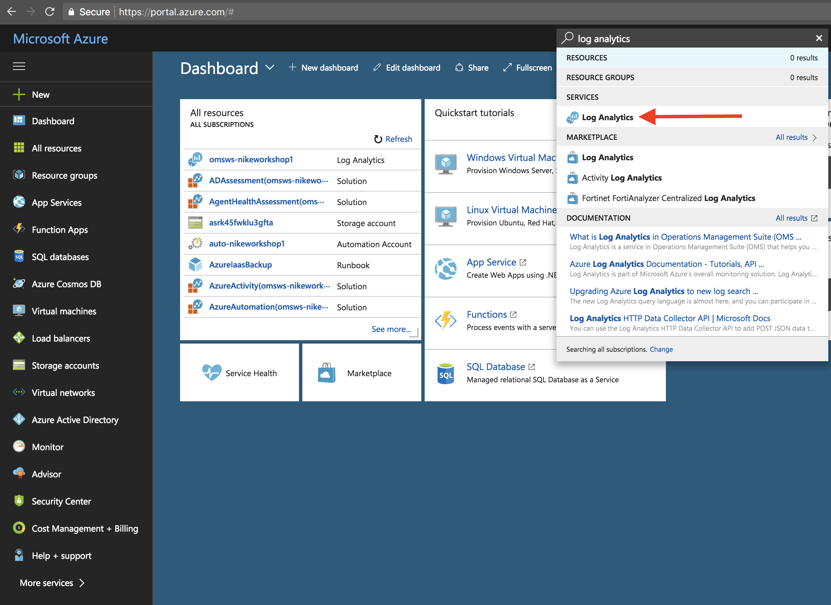

1. Now click on the workspace you created and then click on Advanced Settings.

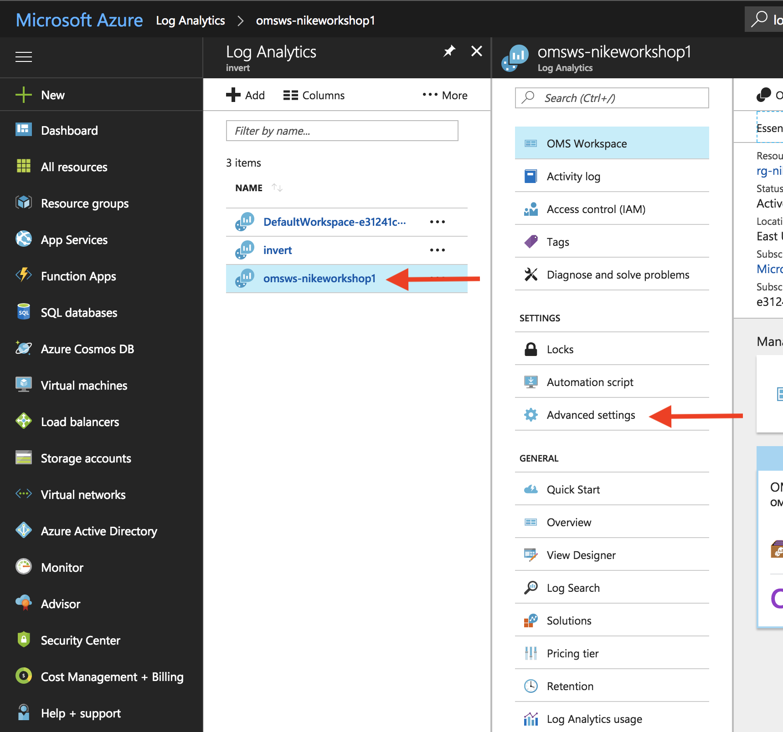

1. This will take you to a screen that shows different operating systems. Click Linux and **then copy your key to notepad**. Please note that there are 2 keys here. The reason for this is to facilitate key rotation. Treat these keys as you would a password or other secret information.

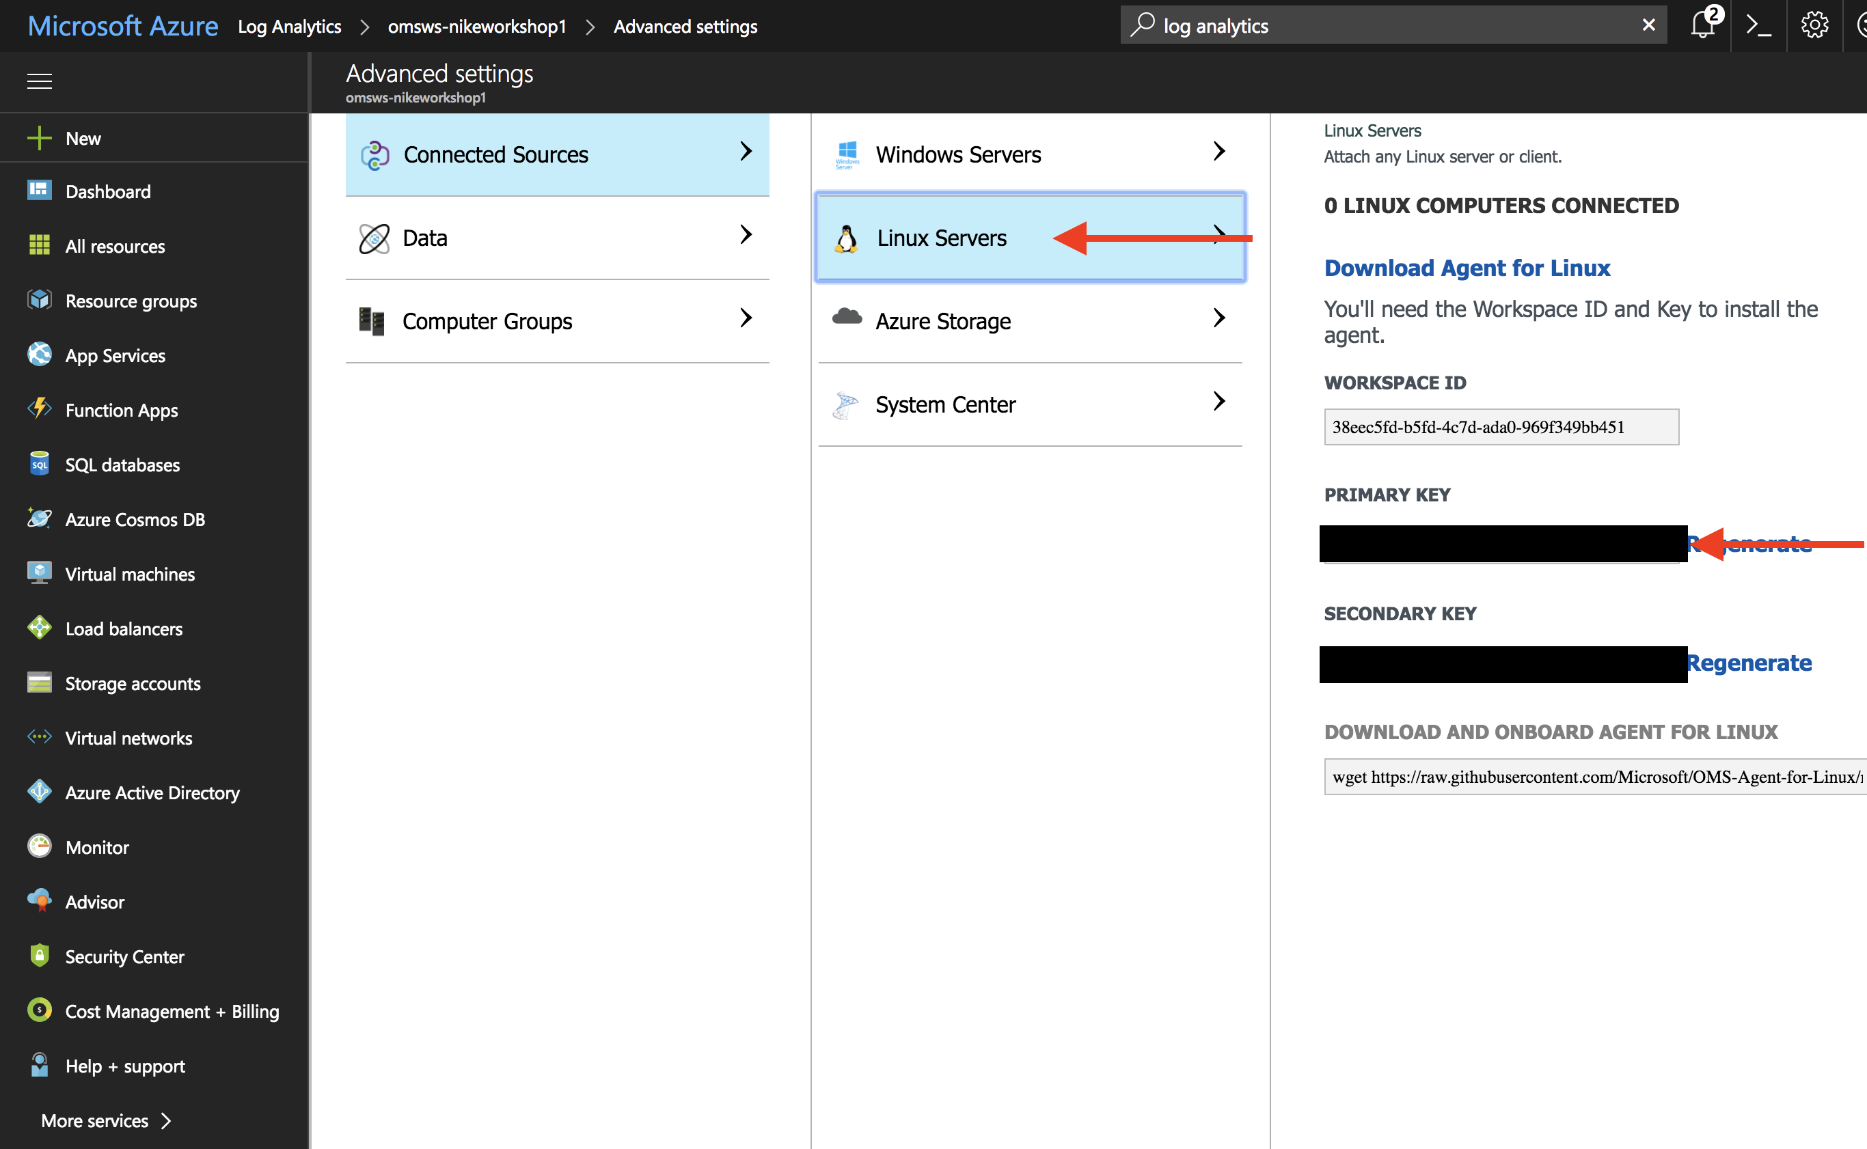

1. Now click Data right below Connected Sources. Then click Linux Performance Counters

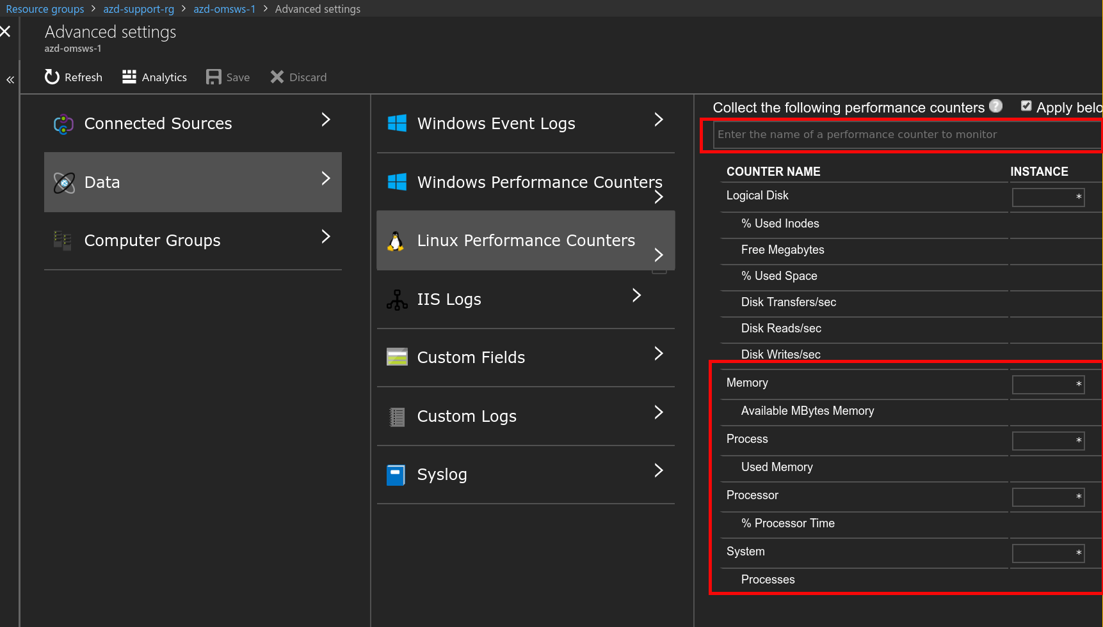

1. Add the counters shown by clicking the box under “Collect the following performance counters”.

# Step 6 – Deploy KeyVault

## Overview

KeyVault is an Azure service that allows you to store passwords, secrets, and cryptographic keys in a secure manner. In this step you will be deploying KeyVault and storing the OMS Workspace key and your SSH public key.

## Detailed Steps

1. **If you don’t yet have an SSH key pair, run the following command to create a key pair.** If you are not sure check the .ssh directory in your home directory. You should see two files, id_rsa.pub and id_rsa. The id_rsa is your secret/private key and should never be shared. The id_rsa.pub is your public key which we will use in this workshop.  
     
   **If you already have a** ~/.ssh/id_rsa.pub **file, there is no need to run the command below.**

ssh-keygen -t rsa -b 2048

1. Edit the deploy-keyvault.sh script in Visual Studio Code. Ensure the SUPPORTRG (resource group name), SUBSCRIPTIONNAME (subscription ID), and OMSKEY are set to the values you used or copied from previous steps. Also ensure the path to your SSH public key matches what is on your filesystem. **Be sure to use a unique name for KVNAME as it must be globally unique.**

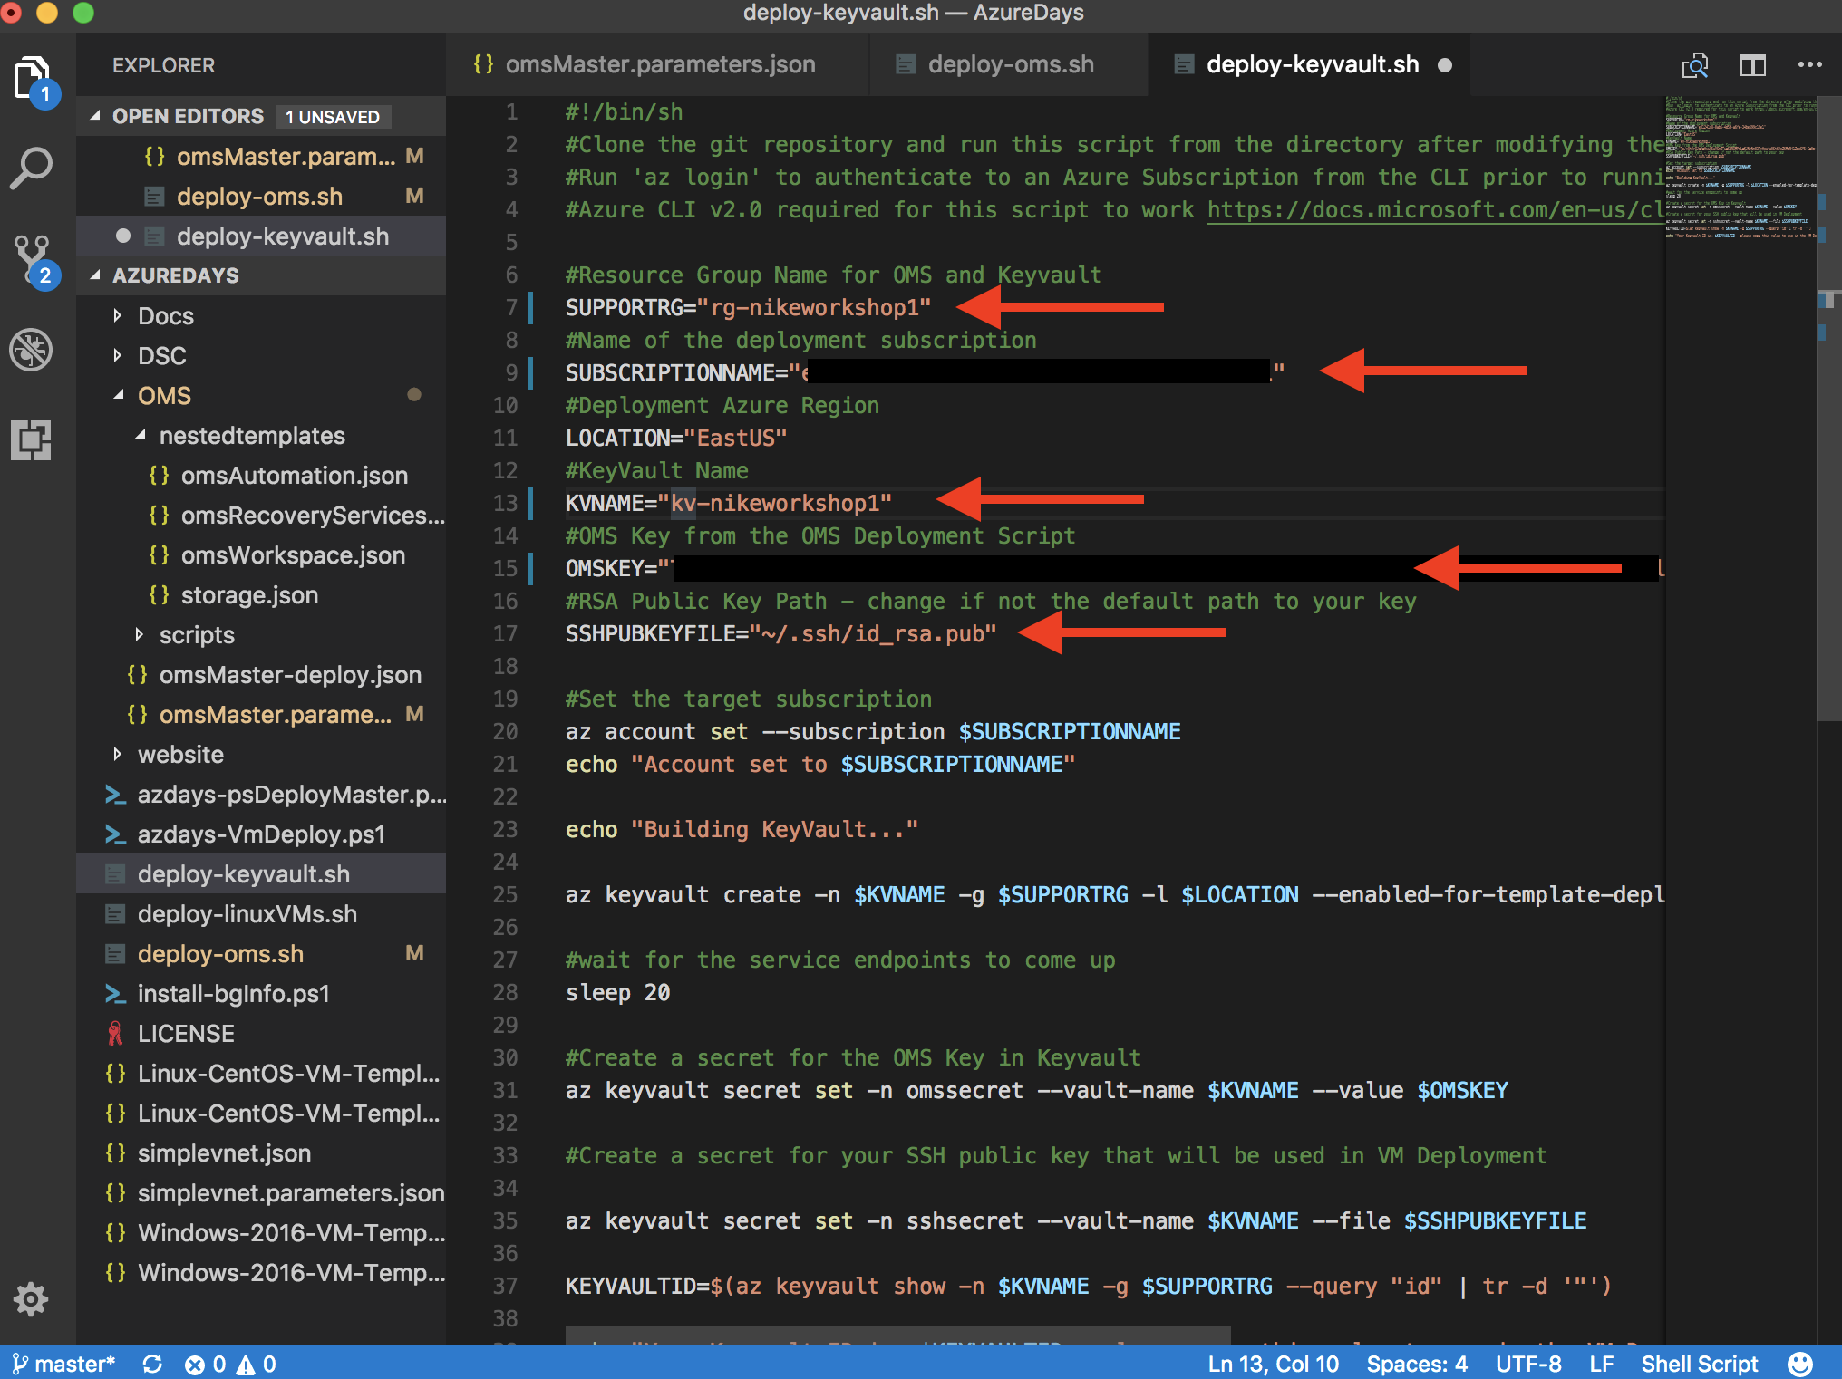

1. Save your changes. File -> Save.
2. Run the deploy-keyvault.sh script in your shell. **Copy the KeyVault ID to notepad when the script is complete**.

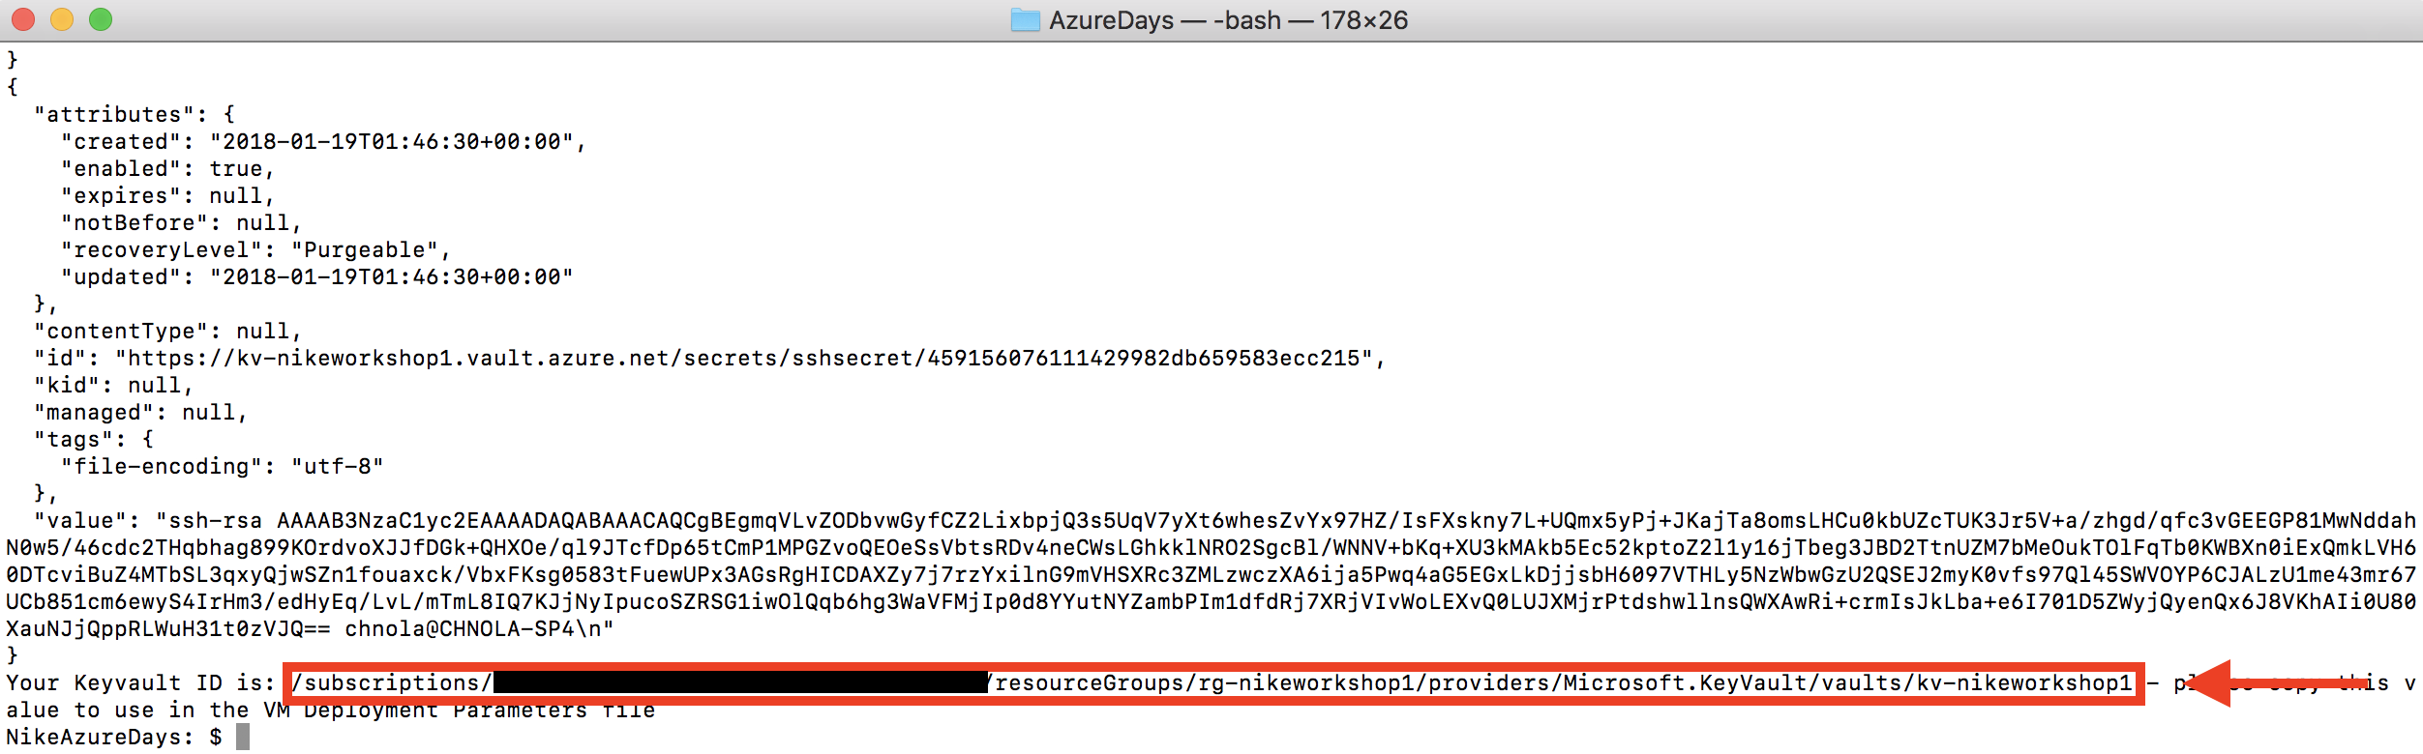

1. To see the keys that are stored in your vault you can use the Azure CLI v2.0 tool.

az keyvault secret list --vault-name <keyvault name>

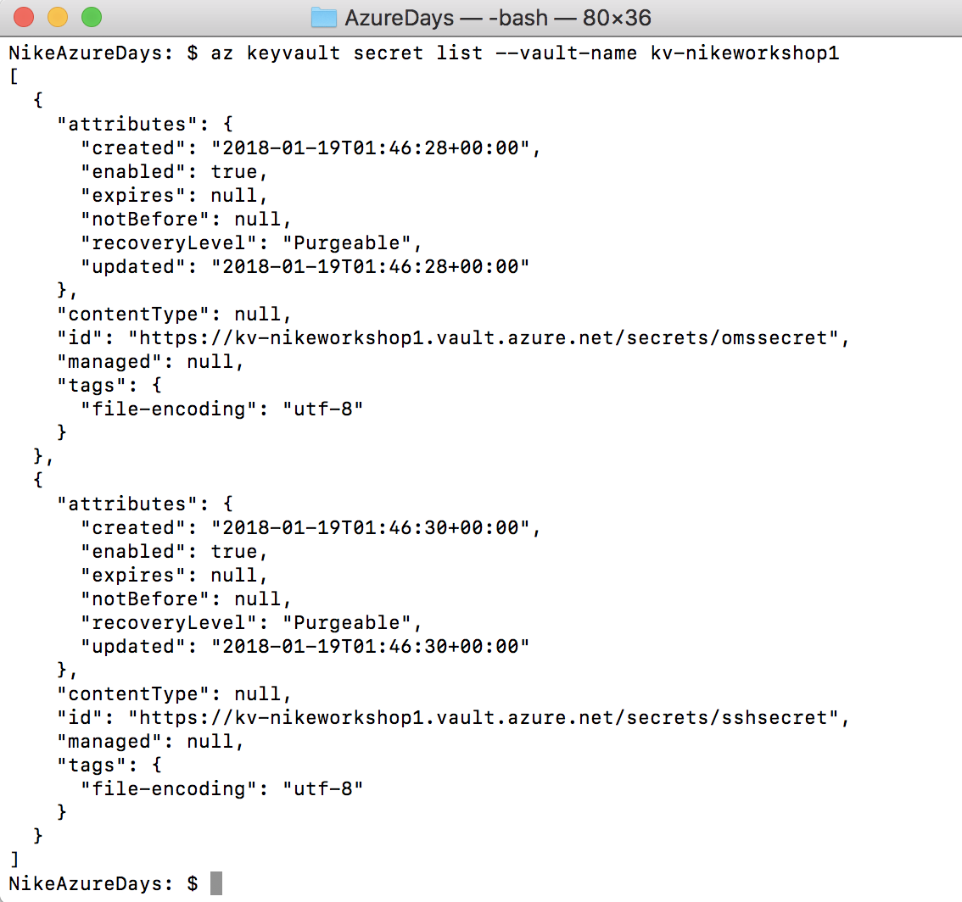

# Step 7 – Deploy Website Content

## Overview

As we’ll be deploying a static website, we need to have a way to deploy that website content to a central location where the web servers we’ll be creating in a later step can access it. We’ve chosen to use Azure Blob Storage – which is a scalable and distributed storage service that can be utilized for serving content to apps, users and websites.

In this step, we will use either a script that utilizes a python tool called “blobxfer” to transfer the files as part of the automation, or if you don’t have a working installation of python/blobxfer, then we will use Azure Storage Explorer – which is a GUI application for transferring files to and from Azure Storage.

## Deploying website content via script and blobxfer

1. First, check to make sure you have a working blobxfer installation and that the binary is recognized in your $PATH. From your terminal emulator run:

blobxfer –version

You should see a printout that says “blobxfer, version 1.1.0” or something similar. If you just installed blobxfer, you may have to restart your terminal emulator for it to be recognized in your $PATH environment variables.

**\*\*note, if you installed blobxfer as –user in Windows Subsystem for Linux, then you will need to add the path to the blobxfer binary to your path**

**export PATH=$PATH:/home/<username>/.local/bin**

If you get an error, or don’t have blobxfer installed, skip to the section of this step “Deploying website content via Azure Storage Explorer”.

1. Open the deploy-websitecontent.sh script file in the code editor. Ensure that the variable value for SUPPORTG is the same as the one used in previous steps for deploying Keyvault and OMS

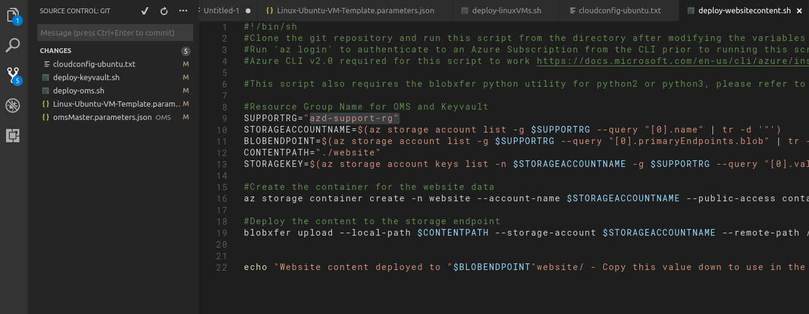

Save your changes to the script.

1. In your terminal emulator, run:

sh deploy-websitecontent.sh

If everything goes correctly, blobxfer will transfer the contents of the local directory “./website” to an Azure Blob Container called “website”.   
  
The script will output the Blob Endpoint Uri (the endpoint where the files can be reached. **Copy the content path to your Notepad**. If you want to verify the content, you can open a browser to the <endpointuri>index.html in a browser to see the staged content.

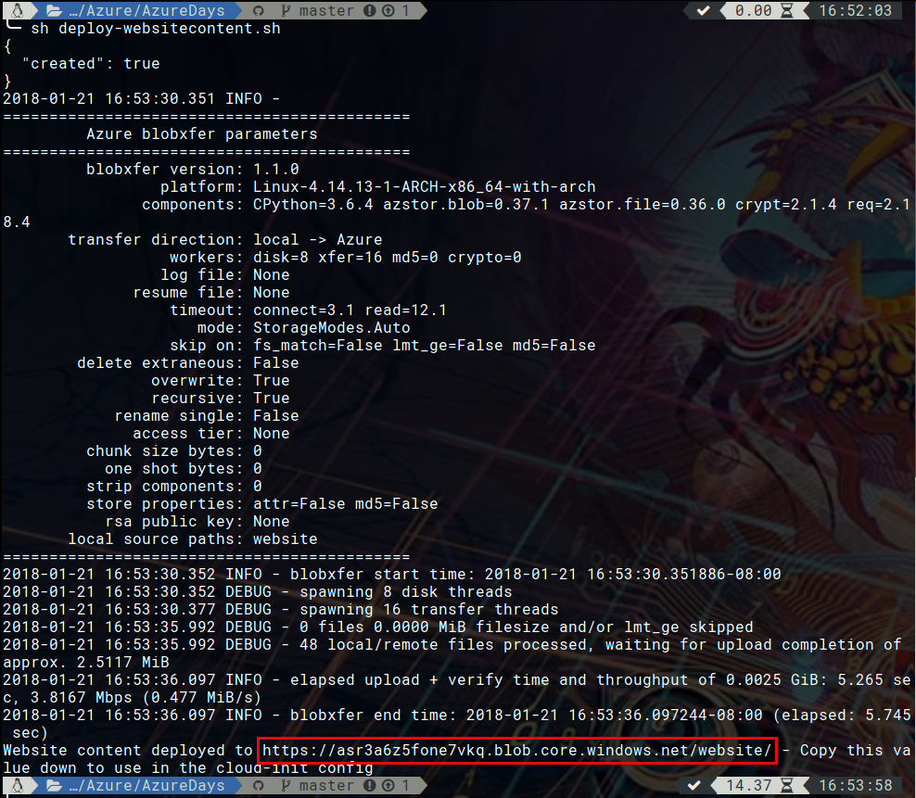  
  
If something goes wrong, you can follow the steps below to deploy using Storage Explorer, just don’t create the website container, it’s likely already there. **If you see the output like above, move on to Step 8**.

## Deploying website content with Azure Storage Explorer

1. Open Storage Explorer on your PC, MAC or Linux system. On first run, there will be a dialogue asking how you want to connect to Azure Storage. Click ‘Sign In’ and log in to your subscription.
2. In the main window, navigate to your storage account (it should be the only one) and then click ‘Blob Containers’

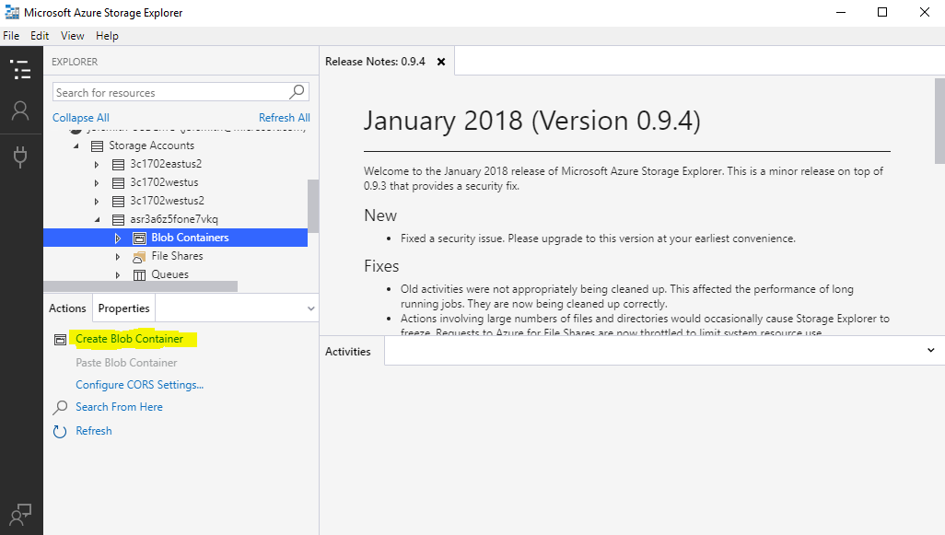

1. If there is no container called ‘website’ already, click “Create Blob Container” and name it ‘website’ (all lower case).

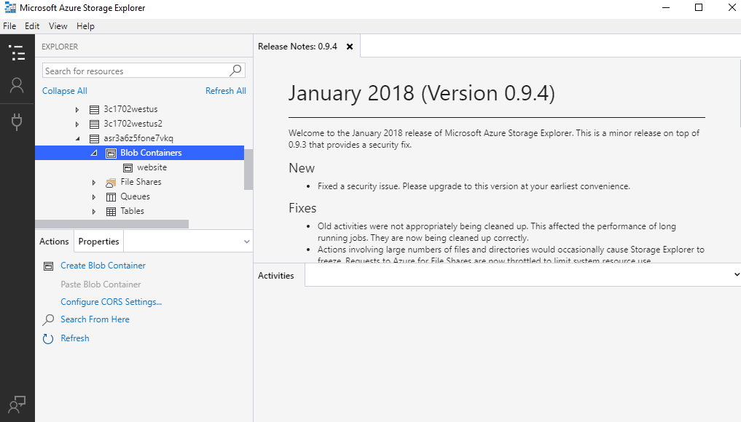

1. Click the ‘website’ container, click the Upload button and select ‘Upload Files’.

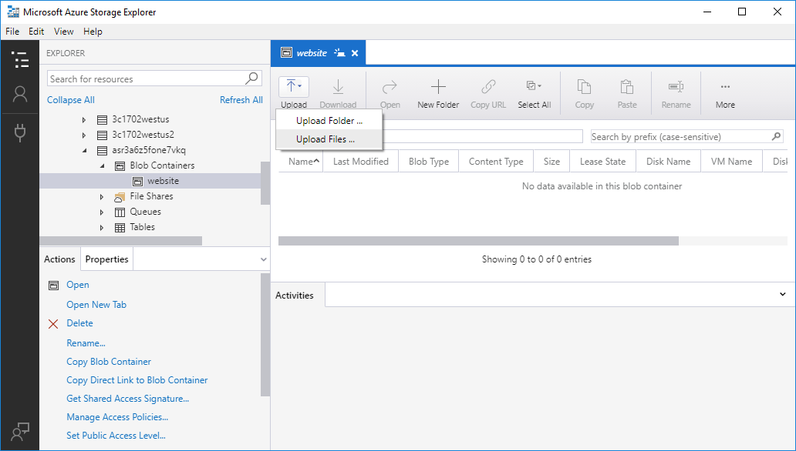

1. Click the Ellipses (…) button and browse to the AzureDays repository folder cloned from Github. Navigate into the folder called website and select all files and folders in the website directory by using Shift+click. Click Open.  
     
   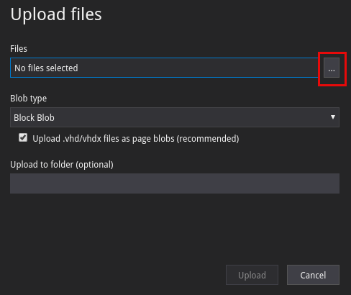

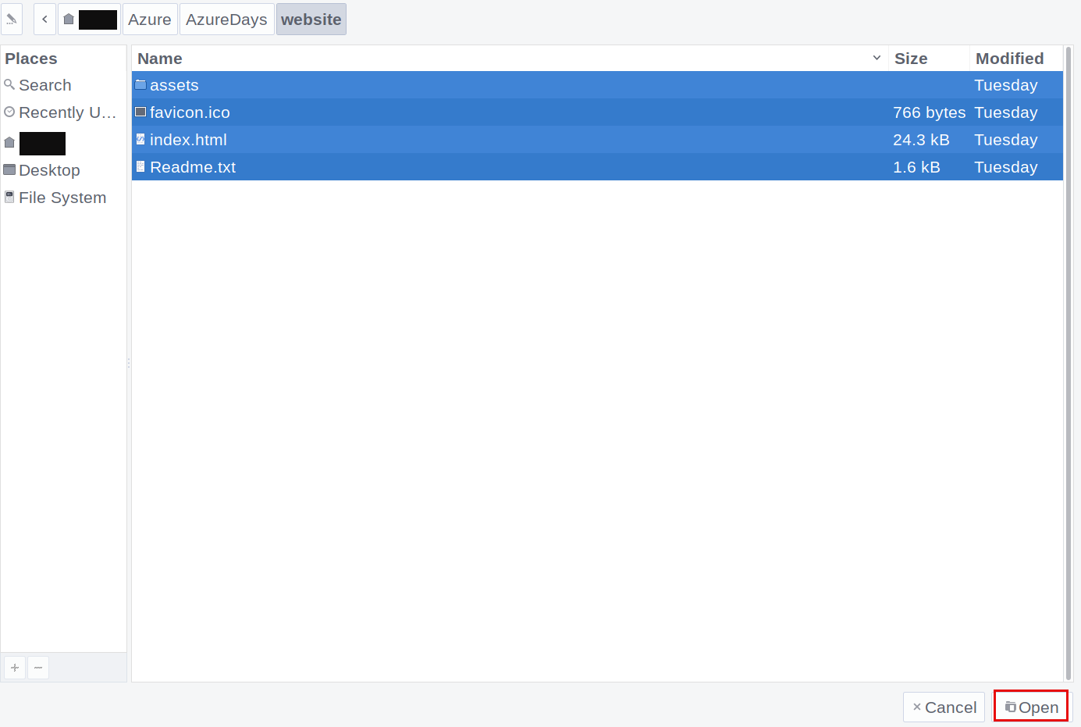

1. Click the Upload button.   
     
   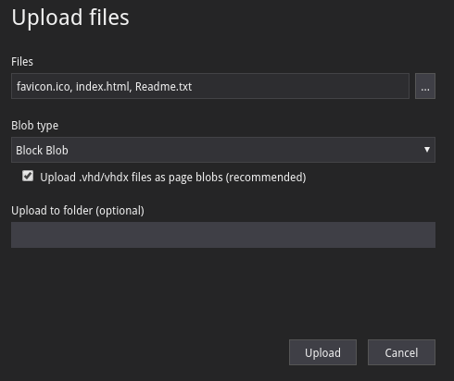
2. This will upload all the **Files** in the root of /website. We still need the folder ‘assets’ however.
3. Click the Upload button again, and this time select ‘Folder’. Follow the same procedure as above to upload the ‘assets’ folder to the root of the /website container.

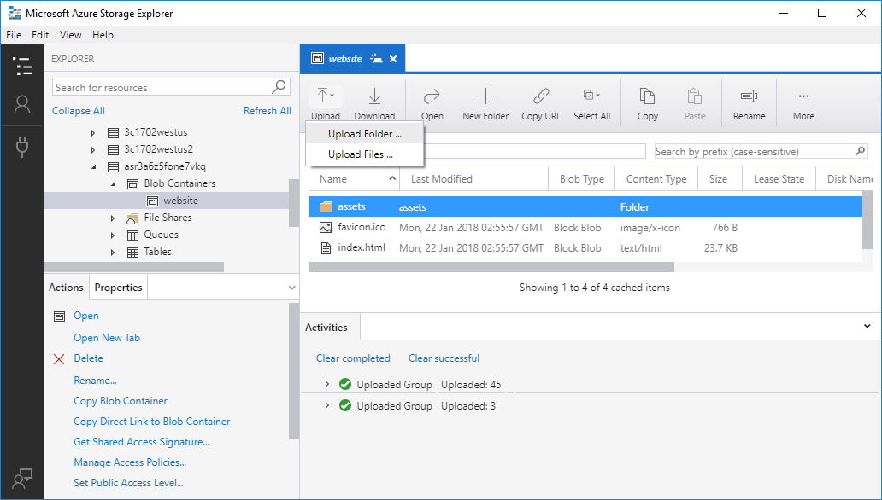

1. Once everything is uploaded, and looks like the above, open your terminal emulator and run the following command where $SUPPORTRG is the resource group name used in the KeyVault and OMS deployment steps:  
     
   az storage account list -g $SUPPORTRG --query "[0].name"   
     
   This will print out the name of your storage account. Copy this value into your notepad.

  
  
This value will be used in the next step to configure the web server deployment.

1. The last step involves setting a Public Access policy to the content. Since our content will be used to serve a public website, we need to make the contents of the Blob Container publicly accessible.   
     
   Click the Container Name under Blob Containers. In the Actions Pane, click “Set Public Access Level”, then ensure the radio button is selected for “Public read access for container and blobs”. If it is not selected, select it and click “Apply”.  
     
   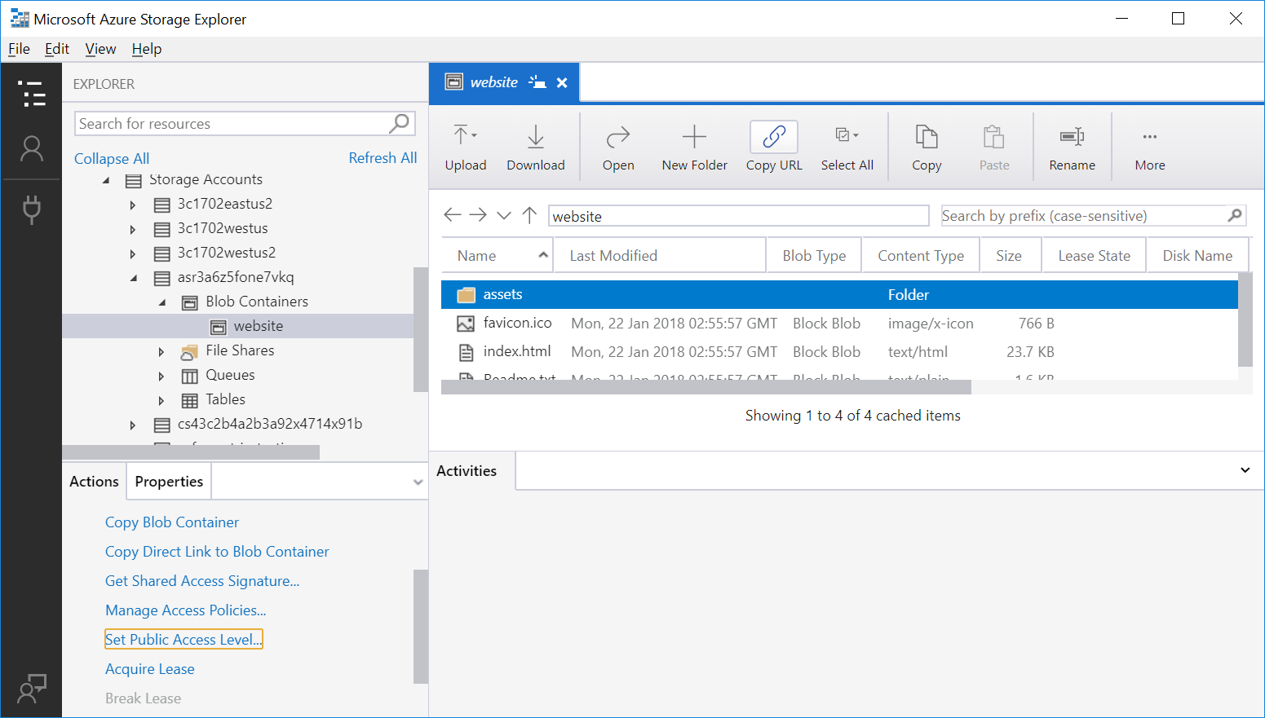  
     
   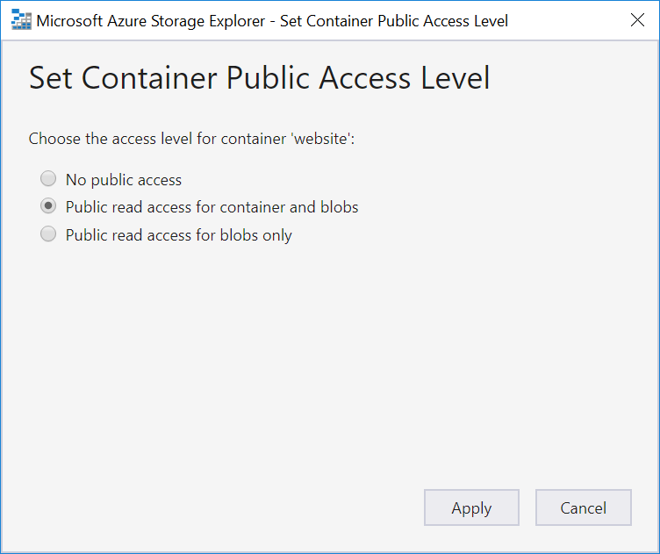

# Step 8 – Deploying the Web Servers

## Overview

In this step, we will deploy a resource group to hold networking components such as a VNET, an Azure Load Balancer, and a public IP address. We will also deploy another resource group with two Linux Virtual Machines, connect them to the internal pool of the load balancer, and use a yml-formatted cloud-init config to install NGINX and configure it to be a proxy for our website content.

## Detailed Steps

1. Open the Linux-Ubuntu-VM-Template.parameters.json parameters file in your code editor.
2. Copy your keyvault Id from Step 6 into the id values for the sshRSAPublicKey and workspaceKey parameters.
3. Edit the adminUsername parameter as desired. Copy the value to your notepad.
4. Copy your OMS Workspace ID obtained in Step 5 into the workspaceID parameter value.

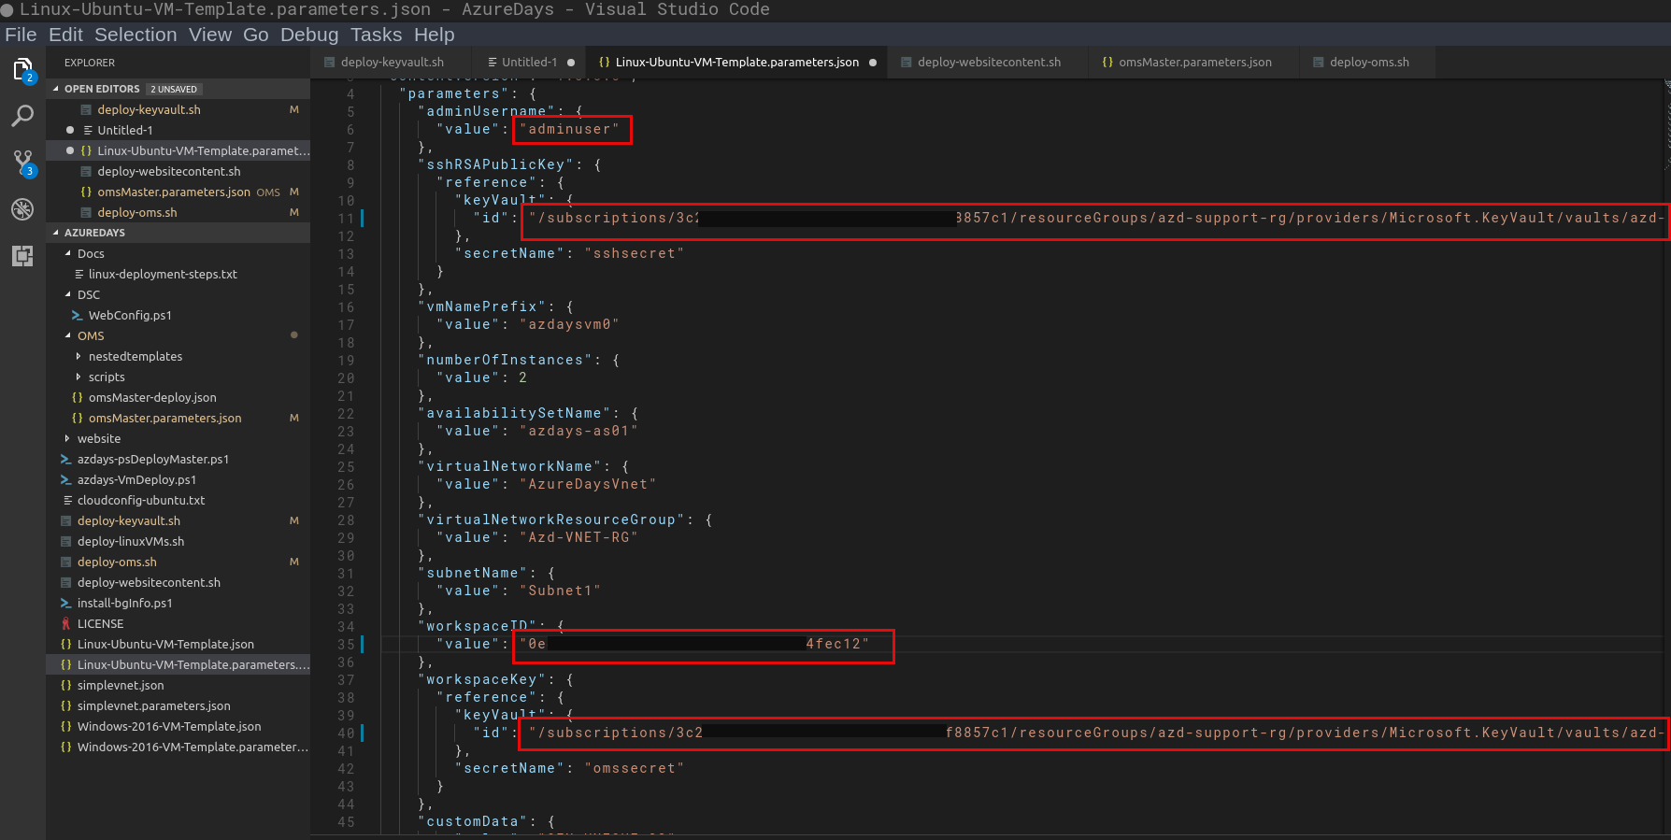

1. Save your changes to the file.
2. Open cloudconfig-ubuntu.txt in your code editor.
3. Find the line that starts with proxy_pass and edit <storage_account_name> to the storage account name you queried for in the command line at the end of the last step.  
     
   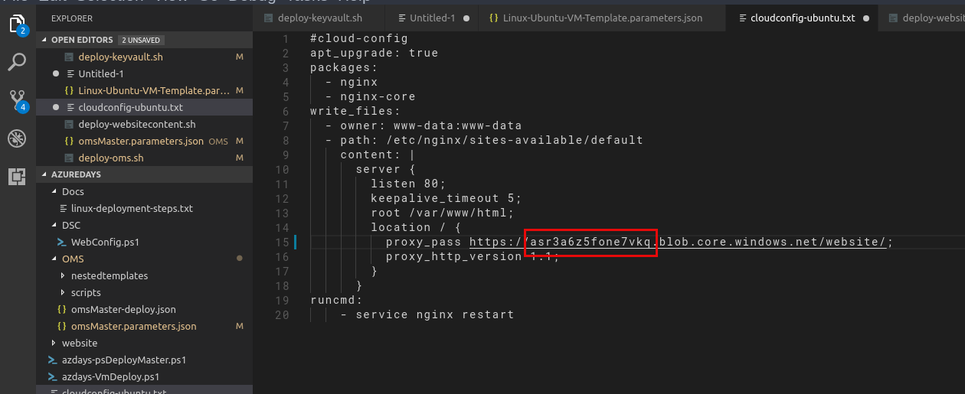
4. Save the file.
5. Open the deploy-linuxVMs script in the code editor.
6. Edit the LBNAME, PUBLICIPNAME, and DNSNAME variables. Be as unique as possible within reason. Edit the SUBSCRIPTIONNAME variable value with your Subscription ID saved from your notepad.

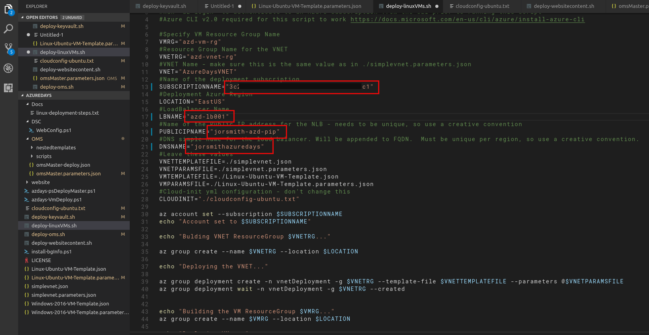

1. Save your work.
2. In your terminal emulator (ensuring that you’re working directory is still the root of the AzureDays cloned repository folder) run:

sh deploy-linuxVMs.sh

1. This will take a bit of time to run – this is where Azure is doing much of the heavy lifting. You can check your deployment status as in Step 5, but there are two resource groups we are deploying into this time. One for networking resources and one for the VMs and their resources.

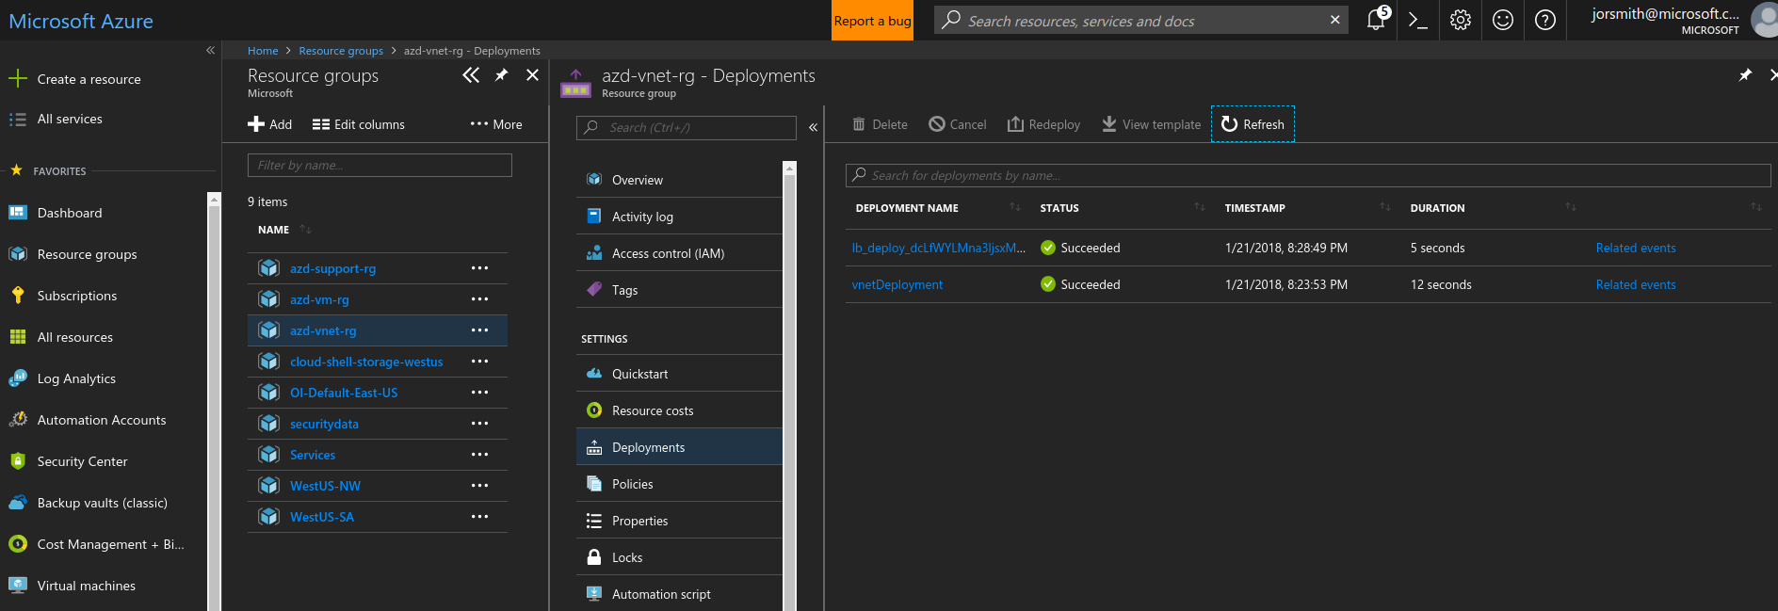

1. The script will output the Public IP address and the address to the load balanced website.
2. SSH into one of the hosts and check if nginx is running. Using the admin username from your notes and the IP address shown in the output of the last step, run:

ssh <youradminuser>@<IPAddress> -p 3441

1. Type yes at the prompt to add the server’s public key to your trusted hosts.
2. Once logged in, run:

pgrep nginx

1. Running process Ids should output. This means that our config was applied. Let’s test the website now.   
     
   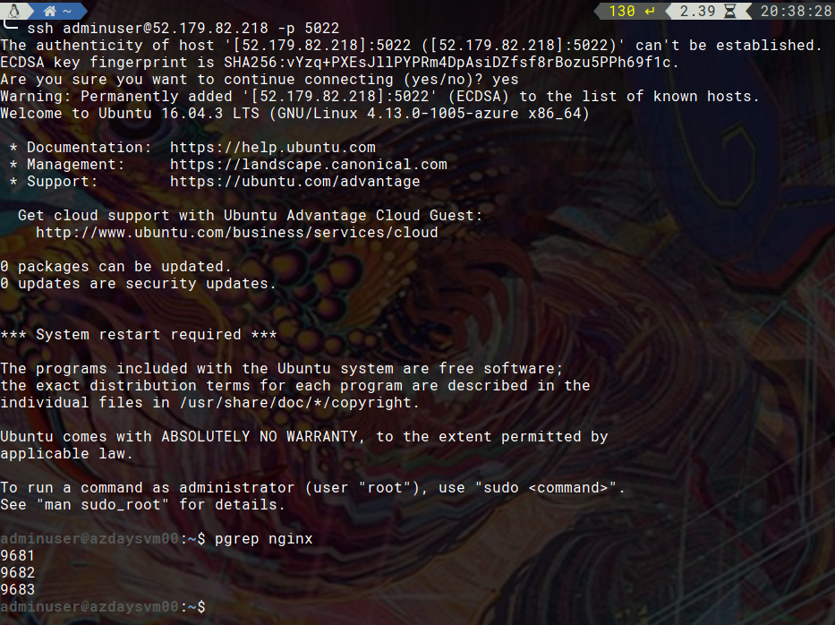
2. Open a browser and go to the Uri that was output at the end of step 14. Make sure it ends in “index.hmtl”, we haven’t configured nginx to automatically display index files.
3. You should see the website content that we’ve deployed  
     
   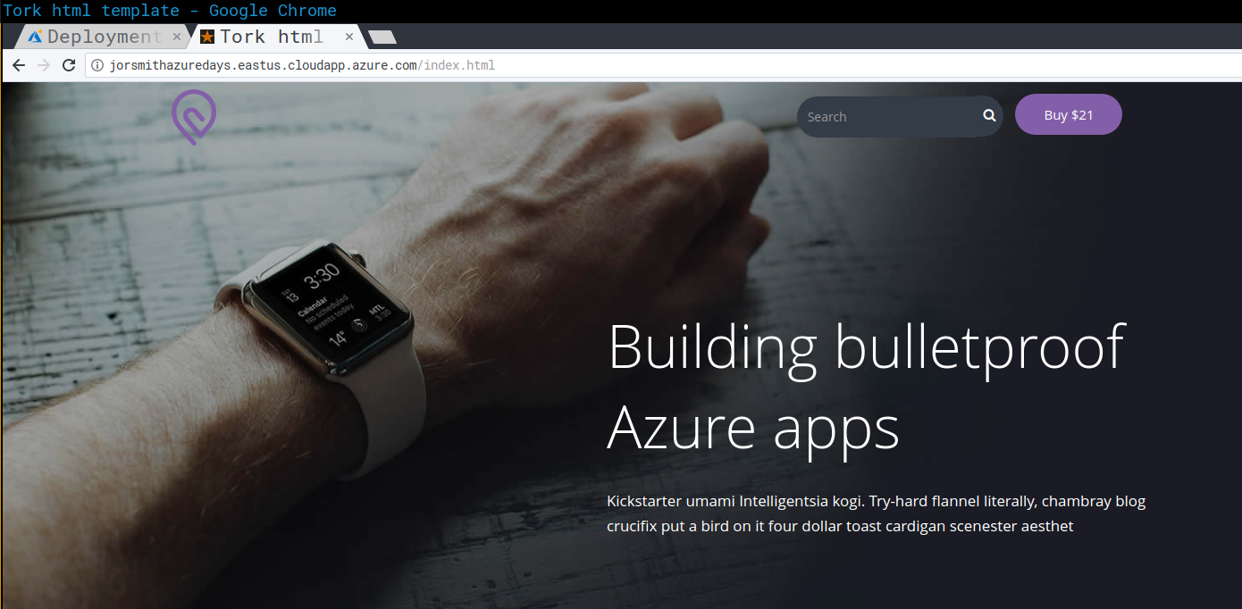

## Testing a failover

1. Make sure your SSH session from the prior steps is closed.
2. List your VMs:   
     
   az vm list -o table  
     
   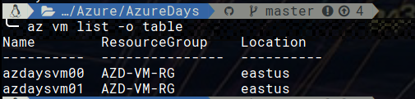
3. Deallocate one of those VMs:  
     
   az vm deallocate -n $vmname -g $resourcegroup  
     
   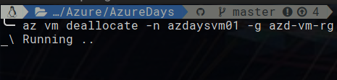
4. While this is running keep refreshing your browser periodically to ensure whether the site stays up.
5. You should notice that even while one host is deallocated the site stays up.   
     
   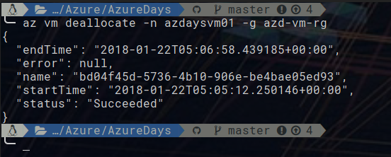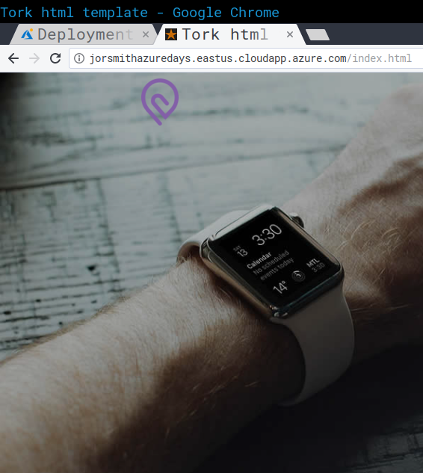

# Step 9 – Monitoring performance

## Overview

In Step 5 we deployed a suite of Azure services called OMS or Operations Management Suite. OMS is a comprehensive management suite for Cloud, Hybrid and On-Premises resources that allows for cross-cloud monitoring, automation and backup/recovery services.   
  
For this workshop, we will be focusing on the monitoring aspect of the Virtual Machines.   
  
Something to note, is that the code for the Virtual Machines to be managed by this service, was part of the deployment template for the VMs. If you remember, we required you to add your OMS workspace ID and a reference to the workspace key stored in Azure KeyVault in your VM Parameters file prior to deployment. This allowed our Microsoft Management Agent to be deployed to the VMs, and for the VM agents to make a connection to the workspace in an automated fashion, and at the time of inception.  
  
Now we’ll explore some of the monitoring telemetry reported to the service. We’ll do this first by creating an Azure Dashboard, then using the Log Analytics service to publish data to it.

## Detailed Steps

1. Log into the Azure Portal <https://portal.azure.com>
2. After logging in, you should be at something called a Dashboard. If you are not, click the “All Services” button on the left, and then search for “dashboard”. Click on the result.

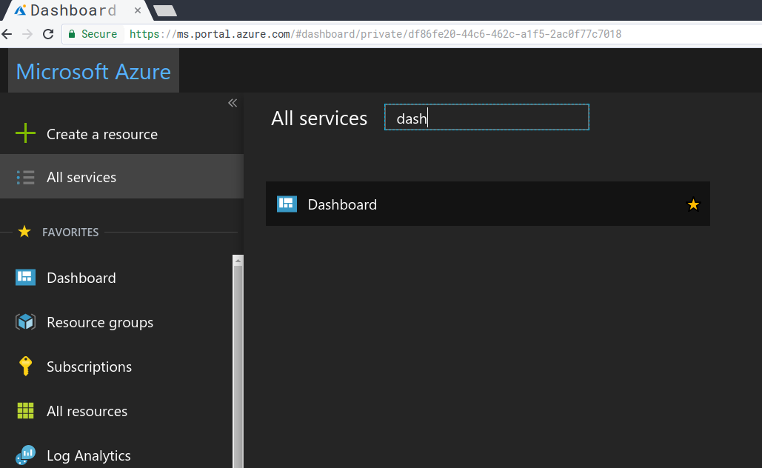

1. The Dashboard service should be displayed. Click the button for “New Dashboard”, then name it something like “Azure Days Dashboard”, or whatever you prefer and can remember. Then click “Done customizing”.

  
  
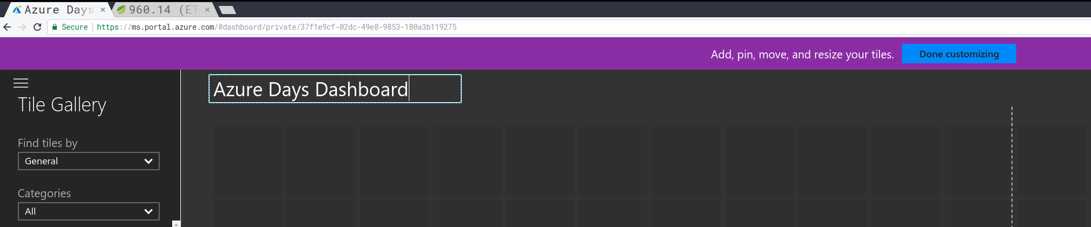

1. You will now be looking at a blank dashboard. That’s ok, we will now share it, so we can publish data to it. Click the Share button at the top of the blank dashboard.



1. A confirmation will show on the right side. It will ask you to pick a Subscription and Resource Group to hold the dashboard metadata. You should be able to leave everything as Default, but you should change the location to EastUS where we deployed the rest of the resources.

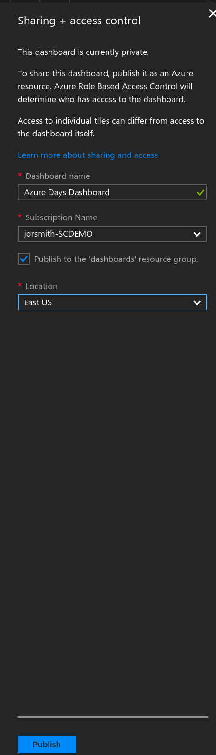  
  
After clicking Publish, you’ll have a blank dashboard and a dialogue to the right letting you set permissions on your dashboard. Ignore this and move on.

1. Click on Resource Groups, then the name of the Support Resource Group specified in Step 4, 5 and 6.
2. Click the Overview blade.
3. You should see a list of resources. Click the resource with the Type “Log Analytics”

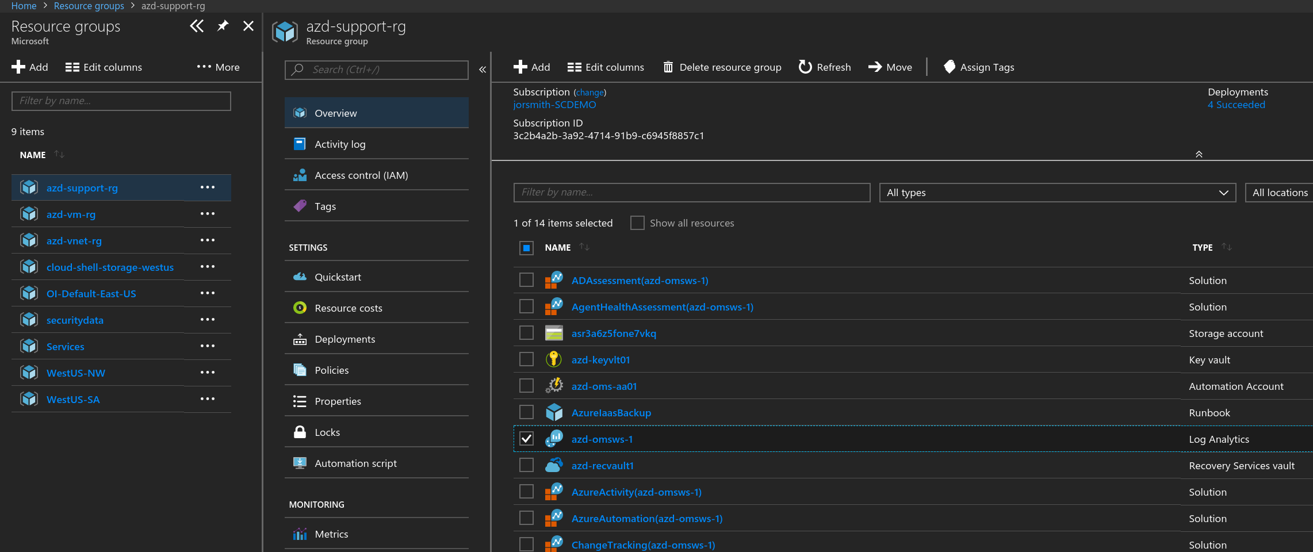  
  
This will bring you to the main Blade view for the Log Analytics service you deployed.  
  
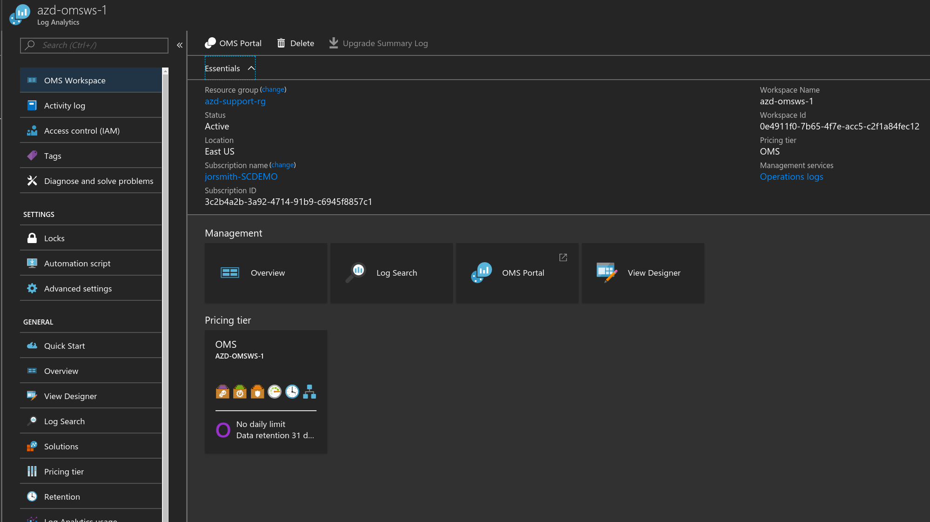

1. Click on Log Search

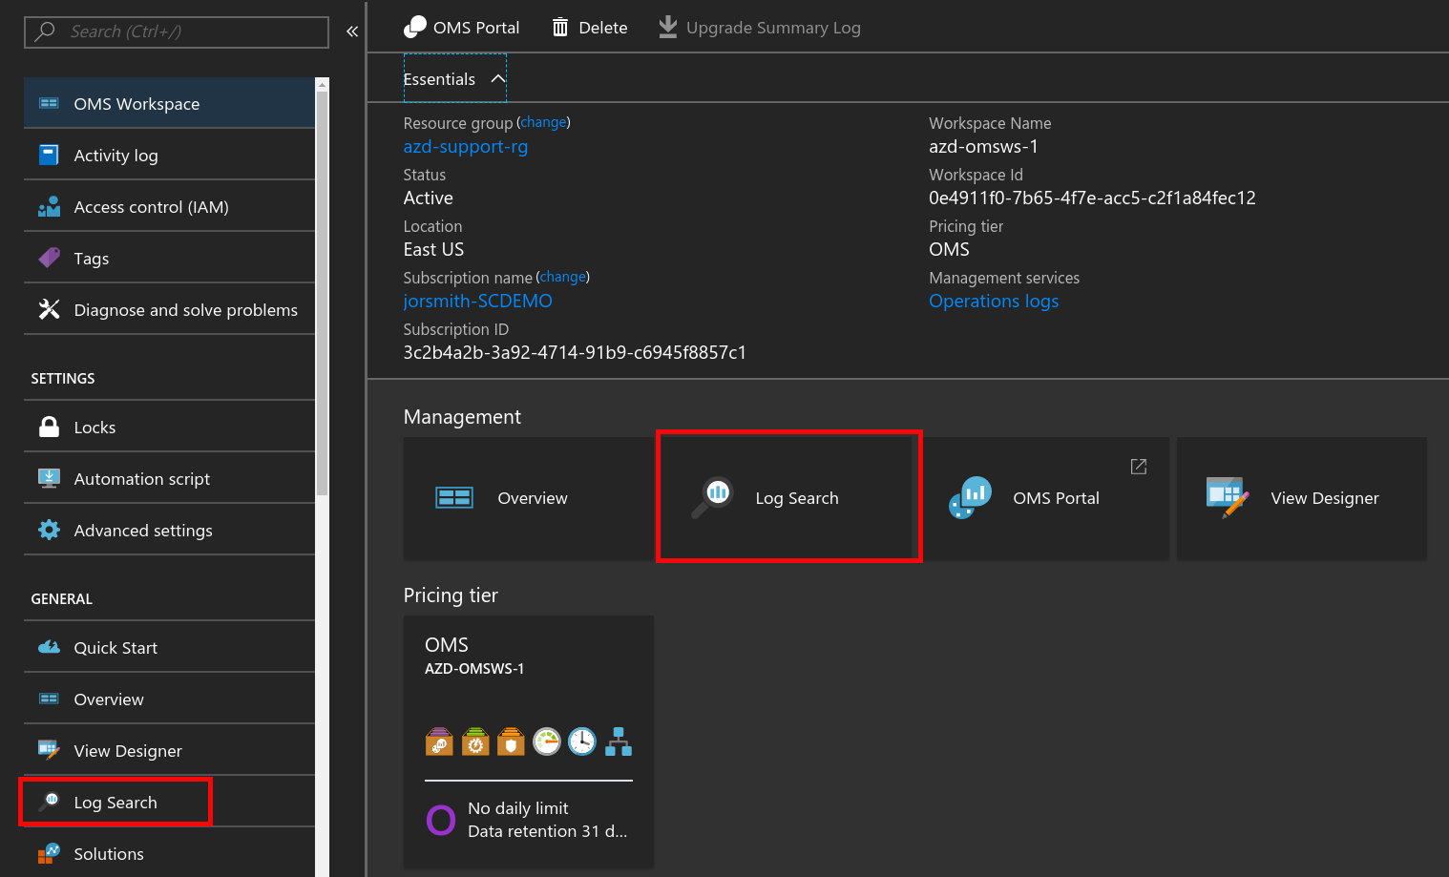

1. In the Log Search blade view, click either the Analytics or Advanced Analytics buttons.

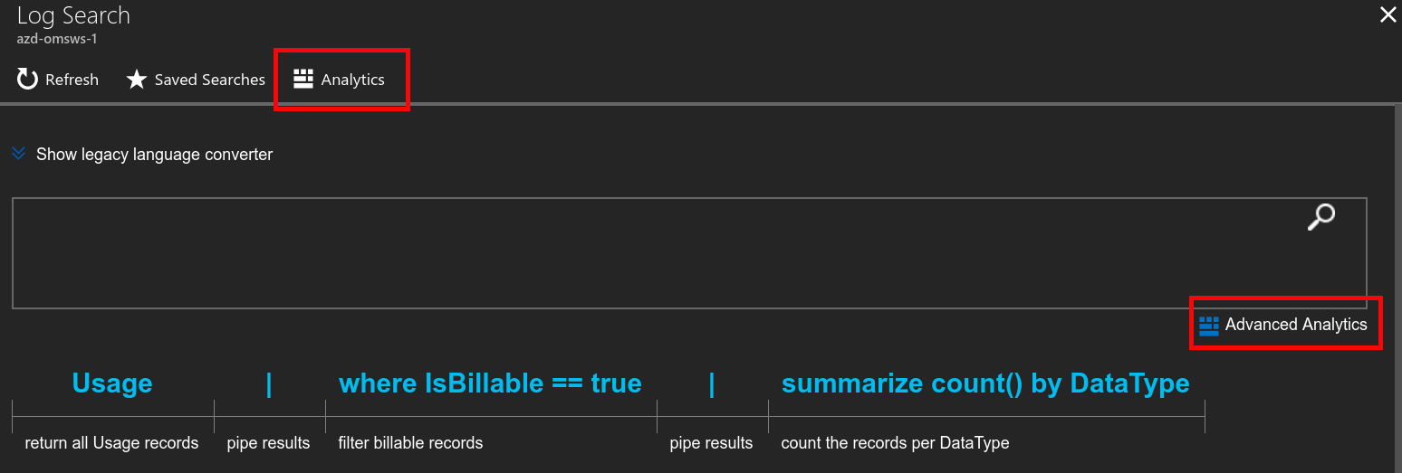

This will take you to the Azure Log Analytics portal. This portal can be used to create complex queries and make them into visualizations that will show on the dashboard you created earlier.  
  
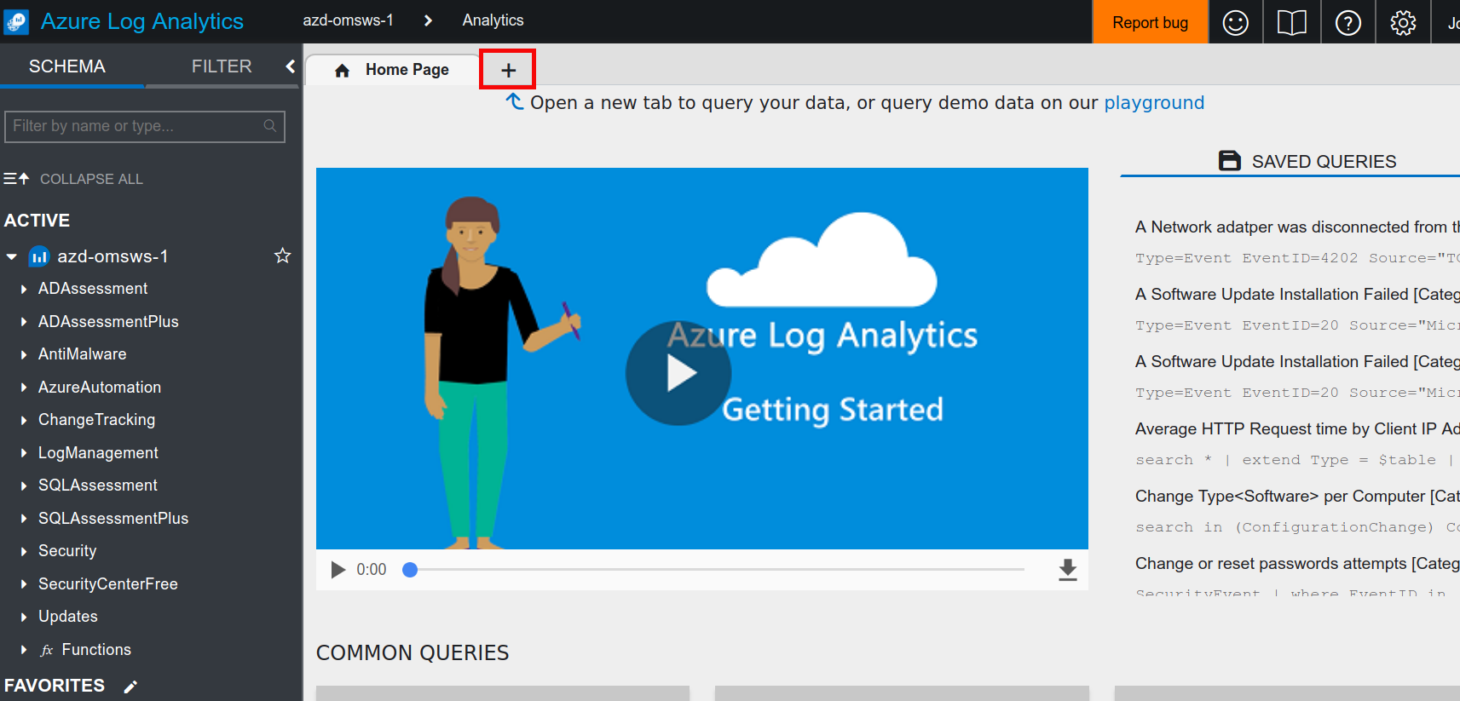

1. Click the ‘+’ to open a new Query editor, then type this query into the editor:   
     
   Perf

| where ObjectName == "Processor"

| where CounterName == "% Processor Time"

| summarize avg(CounterValue) by bin(TimeGenerated, 10m)

| render timechart  
  
Click the RUN button. This will display a graph of the average counter values for the “% Processor Time” counter over the last 10 minutes – for all systems.

1. Click the ‘+’ to open another new query. Now lets look at the individual average processor time over the same period. **note, you can experiment with the length of the timeline by adding to the second parameter in the bin function. i.e. 30m, 1H, 1D, etc.

let vm1 = Heartbeat | where Computer == "azdaysvm00";

let vm2 = Heartbeat | where Computer == "azdaysvm01";

let combinedGroup= union vm1, vm2;

let projectedComputers = combinedGroup | summarize makeset(Computer);

Perf

| where ObjectName == "Processor"

| where CounterName == "% Processor Time"

| where Computer in (projectedComputers)

| summarize avg(CounterValue) by bin(TimeGenerated, 10m) , Computer

| render timechart

1. Click the Pin as shown below so we can pin this to our dashboard.

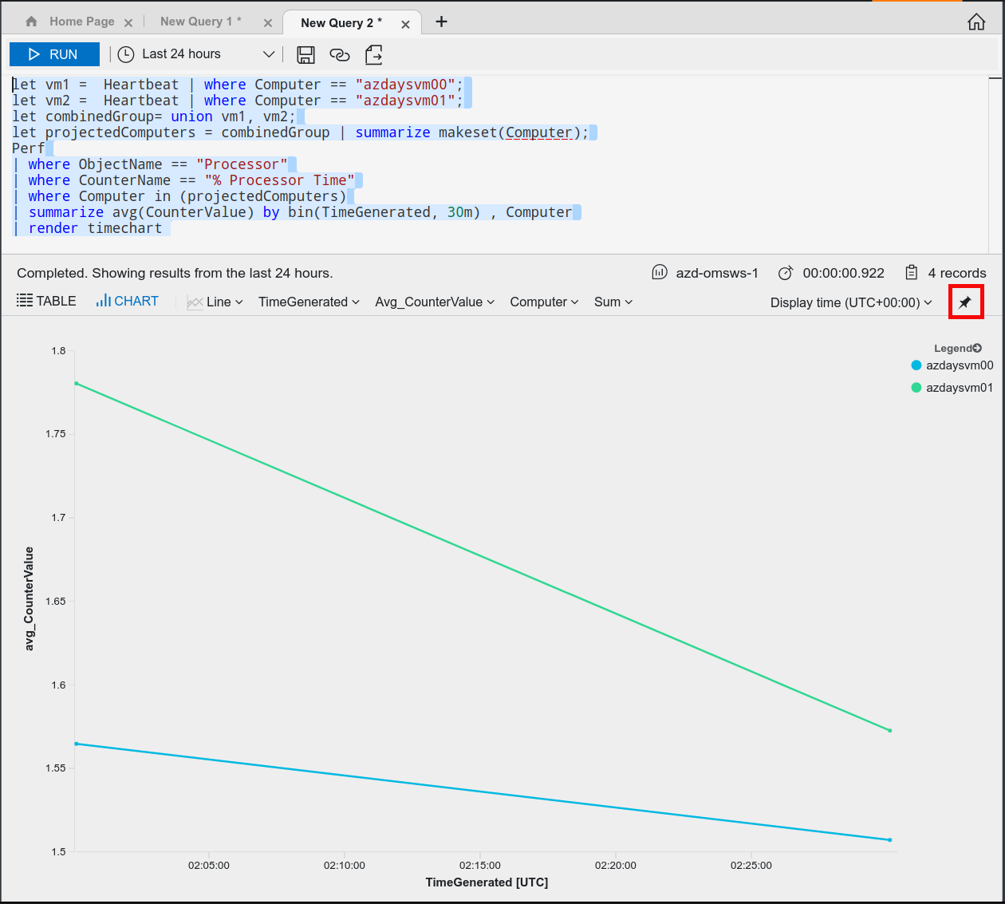

1. Select your shared dashboard from the previous step and then you can click the link to see the visualization presented.

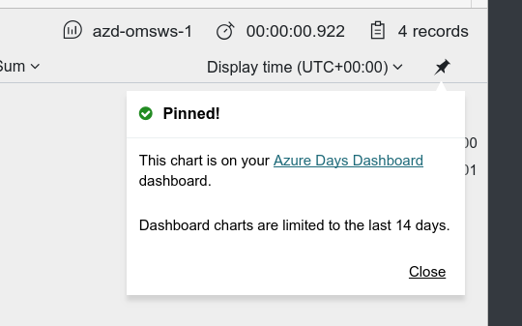

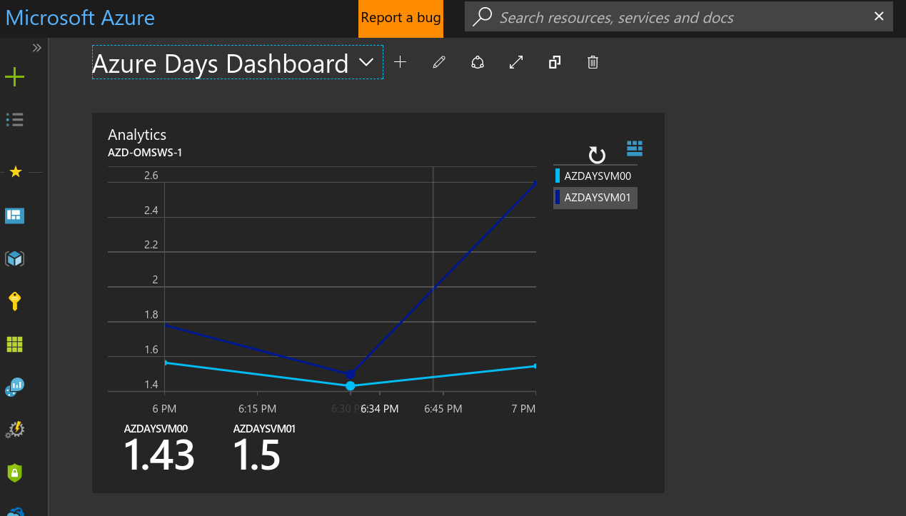

1. Now let’s look at the hourly moving average of performance in 15 minute increments throughout the last day for each VM

let endTime=now();

let timerange =1d;

let startTime=now() - timerange;

let mInterval=4;

let mAvgParm = repeat(1, mInterval);

Perf

| where ObjectName == "Processor"

| where CounterName == "% Processor Time"

| make-series avgCpu=avg(CounterValue) default=0 on TimeGenerated in range(startTime, endTime, 15m) by Computer

| extend moving_avgCpu = series_fir(avgCpu, mAvgParm)

| render timechart

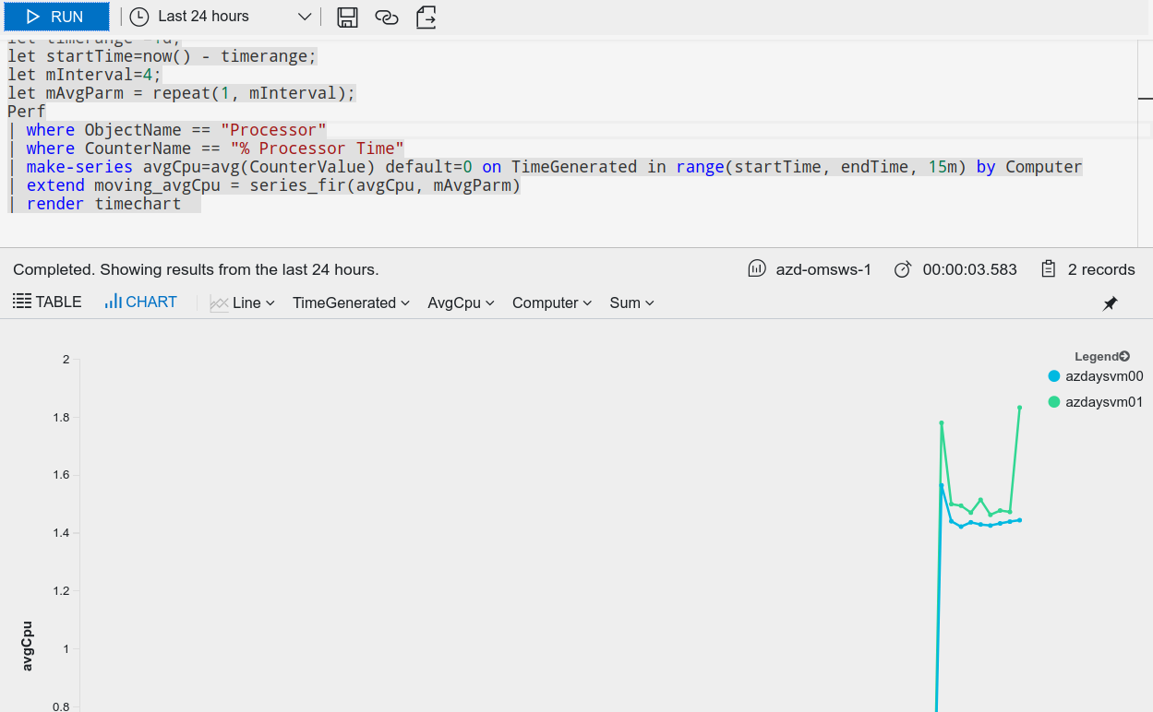

1. Now check how many updates are needed per system

Update

| where UpdateState == "Needed"

| summarize count(Product) by Computer

1. Get a pie chart of syslog errors and warnings per VM to see which VM may need to be inspected. This could also be an indication that this VM is handling more of the traffic

let vm1 = Heartbeat | where Computer == "azdaysvm00";

let vm2 = Heartbeat | where Computer == "azdaysvm01";

let combinedGroup= union vm1, vm2;

let projectedComputers = combinedGroup | summarize makeset(Computer);

Syslog

| where Computer in (projectedComputers)

| summarize count(SeverityLevel) by Computer, SeverityLevel

| render piechart

1. Pin this chart
2. Review your dashboard and edit tile titles and descriptions by hovering over the visualizations you want to change, then clicking the ellipses (…) and click Edit Title.

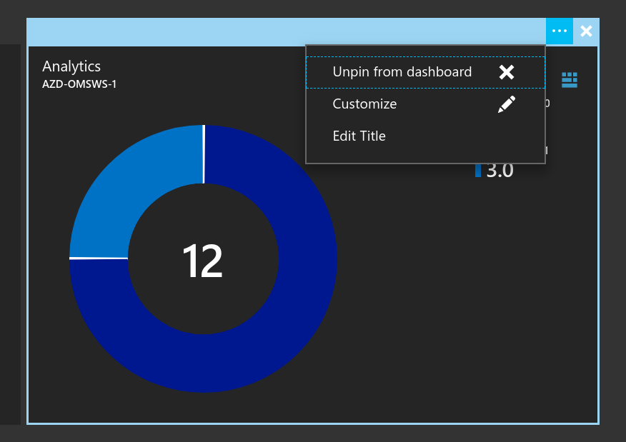

## Extra Credit

Visit the language query reference here: <https://docs.loganalytics.io/docs/Language-Reference>

Produce more queries and a make an even better dashboard!

# Teardown

## Overview

Once we are done working in this environment, we will want to shut it down and delete everything.

## Detailed Steps

1. List all of your resource groups using the az cli command line tool in your terminal emulator

az group list -o table

1. Go through each one and delete each resource group using the following syntax

az group delete -n <name>

Azure will confirm, hit ‘y’ and Enter when prompted.